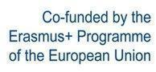

“3D4CE”
3D Printing: A Cultural accelerator for Education

Project code: 2020-1-EL01-KA227-SCH-094618

Erasmus+ Call: 2020 - KA2 - Cooperation for Innovation and the Exchange of Good Practices
KA227-Partnerships For Creativity

Intellectual Output 3
3D Printing and 3D Scanning

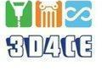

Table of contents
1. Methodology 4
2. 3D pens 5
2.1 Pros and cons of 3D pens 8
2.2 3D pens in education 8
2.3 Develop a curriculum using 3D pens 9
2.4 Equipment 10
3. 3D Printing 11
3.1 3D Printing process 11
3.2 The 3D technologies 12
3.3 3D Printing materials 13
3.3.1 Powders 14
3.3.2 Resins 14
3.3.3 Plastic 15
3.3.4 Ceramic 16
3.3.5 Metal 16
3.3.6 New materials 18
3.4 Applications of 3D Printing 18
3.5 Benefits of 3D printing 22
3.6 Limitations of 3D Printing 24
3.7 3D Printing in education 26
3.8 3D Printing in Cultural Heritage 27
3.8 3D4CE Curriculum 30
3.9 3D Printers 34
4. 3D Scanning 36
4.1 3D Scanning methods 36
4.1.1 Laser 3D scanning 38
4.1.2 Structured Light Scanning 39
4.2 Photogrammetry 40
4.3 Applications of 3D Scanning 42
4.4 Advantages and Challenges of 3D scanning 45
4.5 3D Scanning in Education 45
4.6 3D Scanning in Cultural Heritage 47
4.7 Curricula 49
4.8 Equipment 51
5. 3D Design 53
5.1 3D Design and applications 53
5.2 Advantages and limitations of 3D Design in education and cultural heritage 56
5.3 3D Models libraries 60
5.4 Tinkercad 61
5.5 Blender 61
5.6 Meshmixer 62
6. Conclusions 62
7. Literature review 64

Introduction
This report provides the practical framework of the concepts that the project 3D4CE focuses on. The main aim of the 3D4CE project is to get preprimary and primary students familiarized with the cultural heritage of Europe using 3D Printing technology. Students using 3D printers, can print monuments from the three participating countries (Greece, Italy, and Portugal) as well as monuments around the world. This will enhance their creativity and imagination and help them learn about cultural heritage more easily.
The main task of this Output was to train educators(teachers) to effectively use these technologies, providing necessary knowledge about 3D printing [techniques of 3D printing (Fusion Filament Fabrication, MultiJet Fusion, Electoni Bin Fusion)], 3D scanning [techniques of 3D scanning (Laser 3D Scanning and Photogrammetry)], 3D printing materials and corresponding softwares (Tinkercad, Blender, Sketch up, MeshMixer, Trino etc.). Both QMLab and Privacy Lab, having the corresponding specialization in both fields, trained the teachers that participated in the program in order to train students in the use of 3D printers and the related innovative technologies.
The use of innovative ICT can be a particularly dynamic factor for the development of human capital in the EU regions, strengthening infrastructure, services and products, especially in the field of education, which is crucial for the EU's regional economic development. Therefore, considering EU’s current social and financial conditions, the interrelation of culture, education and ICT is of vital importance.

Methodology

3D Printing is a fundamentally different way of producing parts compared to traditional subtractive methods: a digital model is turned into a physical object by adding material layer by layer. In 3D Printing, no special tools are required. Instead of this, the object is manufactured directly onto the built platform, which leads to a unique set of benefits and limitations. There are three ways to get a final 3D object: design it, find it online (3D model libraries) or using a 3D scanner. To get the 3D model prepared for printing, slicing process is required. During this, a software slices the 3D model into layers. When the file is sliced, a set of parameters such us temperature and speed are defined. Among multiple 3D Printing benefits, geometric complexity at no extra cost is the most important. Furthermore, a wide range of materials can be used during the 3D Printing process, depending on the type of the 3D printer. As for the applications, prototyping, medical implants, automotive, industrial components and architecture are some of them. 3D printing technology can support a wide range of learning processes in primary education, due to the wide range of materials, methods and applications, providing the ability to choose a less complex 3D printing process if needed, suitable for kids. By the end of this intellectual output a specialized curriculum will be developed, containing 3D Printing and 3D Scanning applications and exercises, highlighting the cultural heritage in the context of education.
A considerable amount of literature has been published on 3D Printing technology and its application. Based on this, a curriculum containing multiple activities was developed. Both QMLab and Privacy, created educational content for the teachers. This material contained presentations, educational videos, learning applications about 3D Printing technology etc.
The curriculum includes:
- Introduction of 3D Printing technology and methods for learning design and sketches
- Learning of open sources software that help pupils make their own designs.
- A framework that describes in detail how 3D Printing technology aims students to understand cultural heritage.
- A series of activities for learning cultural heritage and using 3D Printing
- Objectives of each lecture
- A set of indicators in order to evaluate the potential outcomes.

3D pens

3D pens introduced the world to a new way of interacting with objects using the hands. This technology can be used to create designs, place 3D prints on real-world surfaces and even create virtual objects. Users can easily manipulate objects or even draw shapes from scratch using the 3D pen’s features. A 3D pen extrudes heated plastic from its nozzle in order to create the final object. These machines do not require a software to work. Using a 3D pen, a raised graphic on a piece of paper or any flat surface can be created, as it has the ability to “draw” in mid-air, allowing to instantly form 3D structures.

3D pen technology was created in 2012 by WoobleWorks. After three years of R&D and testing, in January 2017, 3D pens were introduced to the world. While the technology behind the 3D pen is similar to those used in 3D printers, a 3D pen comes in functional form. The use of a typical 3D pen is getting easier every day, allowing users to create a variety of 3D objects while being fun and inexpensive (usually under $50), and at the same time are useful in the classroom and at home. They are also portable and lightweight equipment and that provides an accurate way to capture and convert ideas. A 3D pen is able to work with almost any surface including paper, cardboard, plastic, wood, leather, fabric, and even food. They create multiple paths to move in the three dimensions and also allow to erase with ease. (Alom, 2022)

The typical procedure of using a 3D pen begins by feeding plastic through the pen, which then melts it before it comes out of a nozzle at the end of the pen (called extrusion). The pen heats up to a different temperature depending on the material that is inserted. Leaving the pen, the melted plastic is soft and malleable, but within a few seconds it solidifies, creating a solid, stable, and able to pick-up structure.
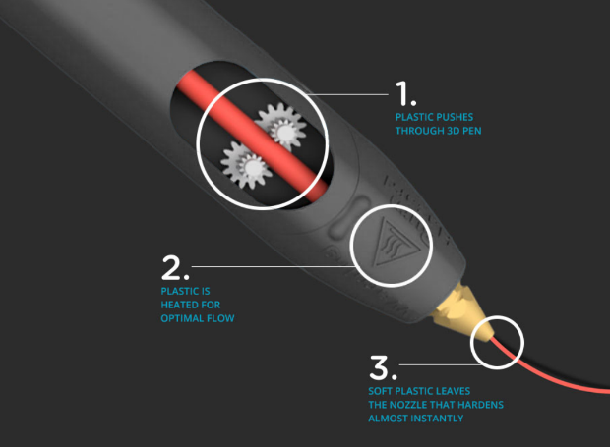

Figure 1 3D pen, Image source https://learn.the3doodler.com/about/what-is-a-3d-pen/

A 3D Pen is a lot easier to learn than traditional two-dimensional drawing as it uses a variety of materials. ABS is the best choice for drawing in the air and first-time Doodlers. PLA is probably the most popular and versatile plastic and is the best option for Doodling directly on surfaces. FLEXY is a rubberized plastic that stays flexible long after it dries. WOOD material is made with real wood fiber and can be sanded once dry. METAL material is made from real bronze and copper and creates sturdy and heavier structures that can be polished for more shine. NYLON has a fabric-like feel and can be dyed into different colors with fabric dyes. (What is a 3D Pen? n.d.)

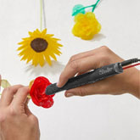 | 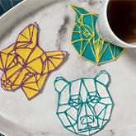 | 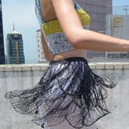
 | 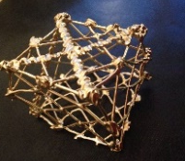 | 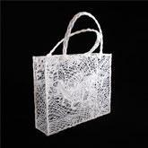
Figure 2 3D pen materials, Image source: https://learn.the3doodler.com/about/what-is-a-3d-pen/

- Handmade Jewelry
3D pens are a new and exciting way to create jewelry. Intricate designs and patterns can be created that would be impossible with traditional techniques. Additionally, personalization can be added to existing jewelry by adding initials, names, or dates while 3D pen jewelry is relatively inexpensive and easy to make.

- Architectural Model
A 3D pen can be a great way to create architectural models, since it can draw vertical and horizontal lines, as well as curves and other shapes. Details can be added such as windows, doors, and roofs. Entire cities or build detailed models of individual buildings, landscapes and miniature replicas of famous landmarks can be created.

- Artwork
Using a 3D pen, dimension and texture to any drawing or picture can be added by simply tracing the outline of a design with the pen and then filling it in with color. Details like stripes, polka dots or even words can be added. The artwork that can be viewed from all angles, making it truly unique. A 3D pen can bring pictures to life by adding dimension and depth. This will create a more realistic look that is closer to the real thing.

- Science Diagrams
In math class, a 3D pen can help students visualize concepts. For example, when learning about geometry, students can use a 3D pen to create models of different shapes. This can help them to understand the relationships between different dimensions. It can also be used to create models of functions and equations. This will allow students to see how these concepts work in the real world. Using a 3D pen in math class can be a great way to engage students and help them to better understand complex concepts.

- Repairing with 3D Pen
3D pens are becoming increasingly popular for a variety of tasks, including repairs. While they may not be able to fix everything, 3D pens can be used for a variety of small repairs, such as filling in holes or cracks and bonding broken pieces together. (Ahmed, 2022)

- 3D design and prototyping
Product development in areas like fashion and automotive can be made much easier with a 3D pen. The ability to instantly realize basic 3D shapes is extremely helpful for brainstorming and conceptualizing, suiting both hobbyists and professionals. (Mashambanhaka, 2019)

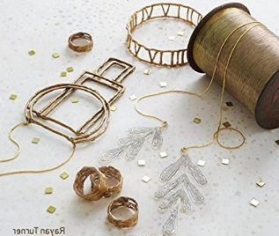 | 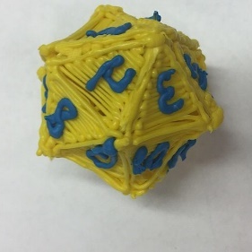
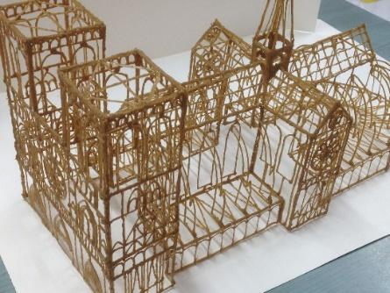 | 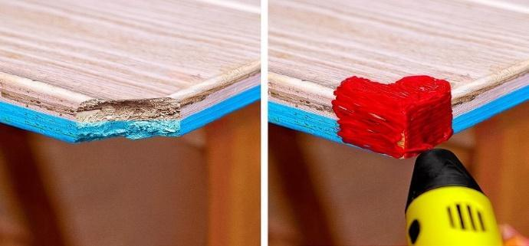
Figure 3 3D pens applications, Image source: https://3dgearguide.com/cool-things-to-make-with-a-3d-pen-for-beginners/

2.1 Pros and cons of 3D pens
Among multiple advantages while using a 3D pen, the most important are:

- Easily draw an object
- No need of extra training on use
- Enhance creativity
- Easy set-up device
- No need of extra software

But also, some disadvantages:
- Not the same texture as an object made from 3D printer
- Limited size of nozzles
- Limited use of materials (mostly work with PLA, ABS)
- Difficulties in complex models

2.2 3D pens in education
3D pens have a wide variety of exercises to offer in a classroom. They create a new perspective, they’re fun, and they have their own charm that makes them special. They can be used in the classroom to help the students engage and interact with materials in a different way. In addition, they provide a fun way for kids to explore math concepts in a hands-on way that engages both their minds and bodies. Additionally, they help teachers, parents, and educators to develop engaging strategies and lessons, helping them to retain the content better and increase the levels of success. 3D pens can be a useful tool in educational settings, particularly in the fields of science, technology, engineering and math (STEM). Some examples of applications of 3D pens in education are:
- Demonstrating concepts: 3D pens can be used to create physical models that help students visualize and understand complex concepts, such as geometric shapes or molecular structure.
- Hands-on learning: 3D pens allow students to engage in hands-on learning by creating their own three-dimensional designs and structures. This can increase engagement and understanding of the educational material being taught.
- Project-based learning: 3D printing pens can be used as part of project-based learning activities, where students work together to design and create a product or solution using the pens.
- Sparking creativity and imagination: 3D printing pens can be used to spark creativity and imagination in students of all ages by allowing students to create their own designs, the pens can help to foster a sense of curiosity and encourage problem-solving skills. (Everything About a 3D Printing Pen, 2018)

2.3 Develop a curriculum using 3D pens
During the 3rd transnational meeting of the 3D4CE project one of the sessions was dedicated to the 3D pens. The session included the description of the 3D pens and the way they work along with the possible usages they can have.
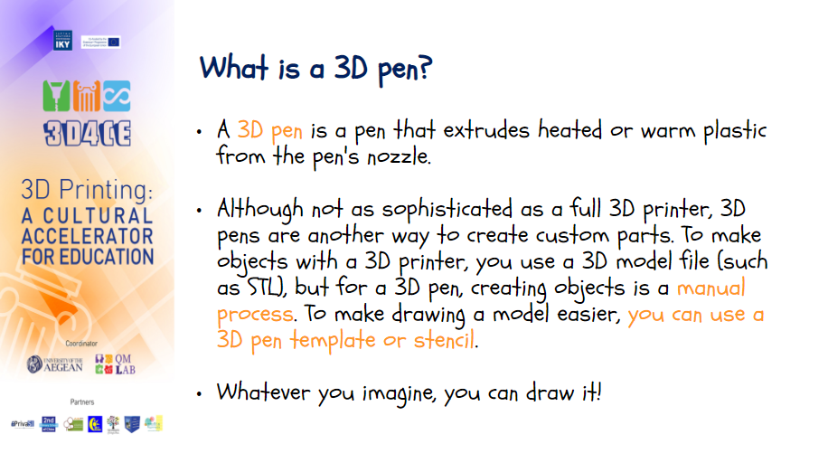 | 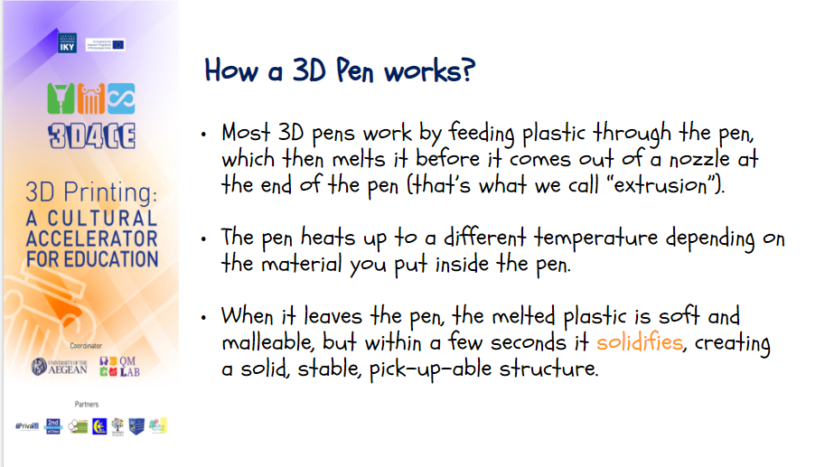
Figure 4: Parts of project’s presentation about 3D pens

Additionally, the materials were explained and detailed description of the equipment used throughout the project was given.

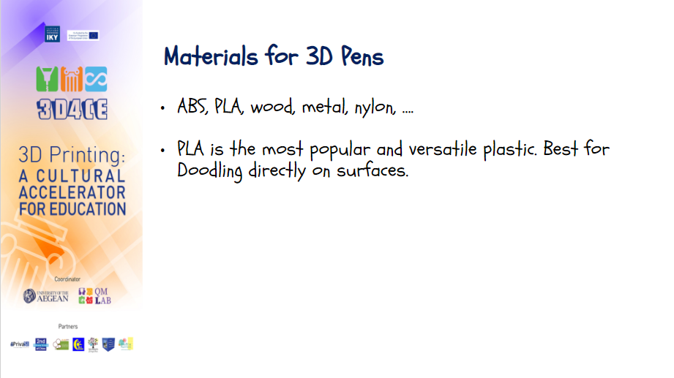 | 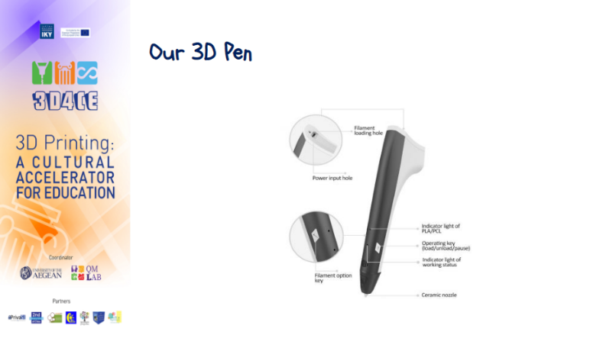
Figure 5: Parts of project’s presentation about 3D pens

Further on, tips were given regarding the usage and best practices of the 3D pens.
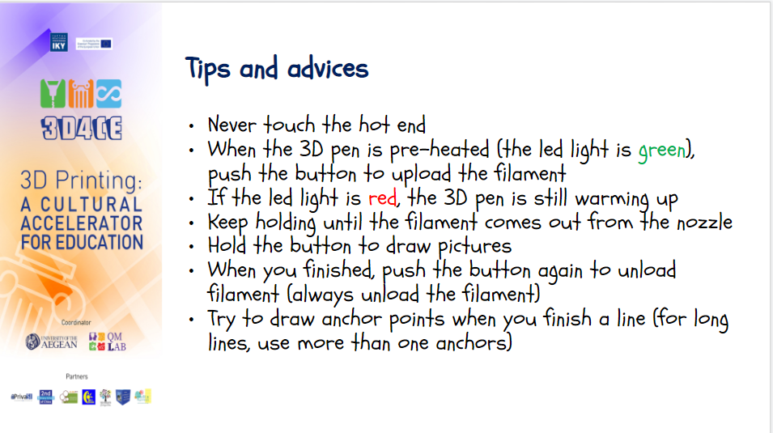

Figure 6: Parts of project’s presentation about 3D pens (tips and advices)

2.4 Equipment
During the 3D4CE project the SUNLU 3D Pen M1 was used. SUNLU M1 is a secure 3D pen that works with PLA and PCL filaments. The SUNLU M1 3D printing pen has a simple one-button operation. The main features of the specific 3D pen include the possibility to choose temperature and cooling modes according to the taste and experience. This pen automatically shutdowns to sleep mode when 30 seconds pass without operation. The optional colors are black, white, red, blue, and yellow. The 3D drawing with low temperature minimizes the risk of burns. They have an optimized design and are easy to maintain. They are small and light weighted. The operating temperature for PLA is 170 ° C and for PCL 55° C.

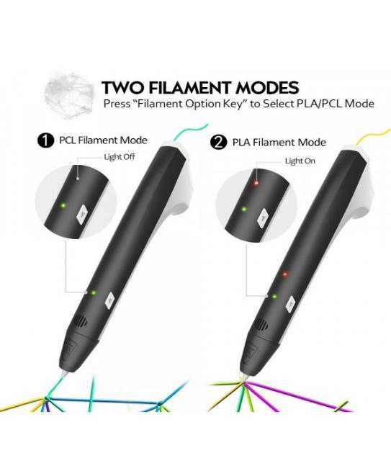

Figure 7: Two Filaments Modes, Image source: https://electrobot.gr/3d-pen-sunlu-m1-black

The single-button operation is an innovative feature that offers a simple and intuitive 3D printing experience. Single button control means that only one button is enough to feed and pull back the filament. Environmentally friendly PLA or child-friendly PCL filaments can be used with this 3D pen. The SUNLU M1 features innovative power supply technology and 3D can be drawn anywhere with an external power supply. A 5V/2A input and an intelligent heating system ensure mobility. The pen can be repowered using a smartphone charging cable or a power bank. The 3D pen is equipped with intelligent heat protection. The unit starts automatic cooling after half a minute after the 3D drawing is finished. Furthermore, the device is equipped with a safety temperature protection and a ceramic nozzle which is much safer than a copper nozzle. The SUNLU M1 3D printing pen is designed for artists, children, and adults. (SUNLU M1 - 3D pen, n.d.)

3D Printing

3.1 3D Printing process
3D Printing or additive manufacturing makes three-dimensional solid objects from a digital file. 3D Printing brings two fundamental innovations: manipulating objects in their digital format and manufacturing new shapes by adding material. 3D Printing typically works by laying down many successive thin layers of material. There are several different techniques to 3D Print an object. 3D Printing is the opposite of subtractive manufacturing which is cutting out/hollowing out a piece of metal or plastic with, for instance, a milling machine. 3D Printing produces complex shapes using less material than traditional manufacturing methods. (3D printing.com, 2022).
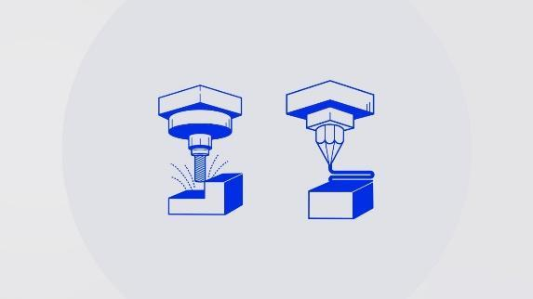  Figure 8: Additive Manufacturing Image source: https://www.roboze.com/en/resources/additive-manufacturing-vs-traditional-manufacturing-cost-and-advantages-of-3d-printing-technology.html | 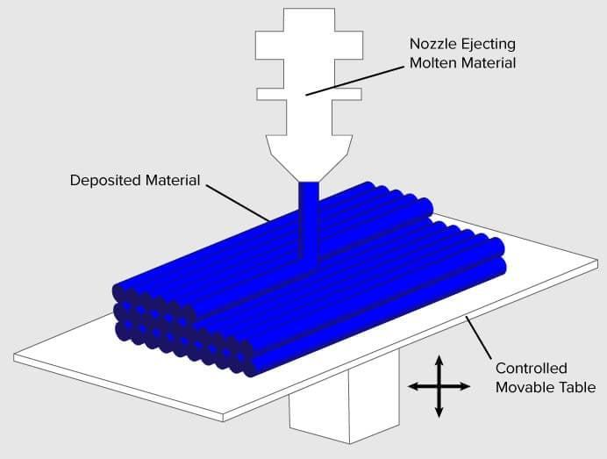  Figure 9: 3D Printing Layers Image source: https://3dprinting.com/what-is-3d-printing/
File preparation and conversion can also become complex and time-consuming, particularly for parts that require intricate support during the build process. However, another critical point is that only some 3D Printing processes come today as plug-and-play options. There are many steps before printing and many more after the part is removed from the printer — called post-processes. (3d Printing Industry, n.d.)
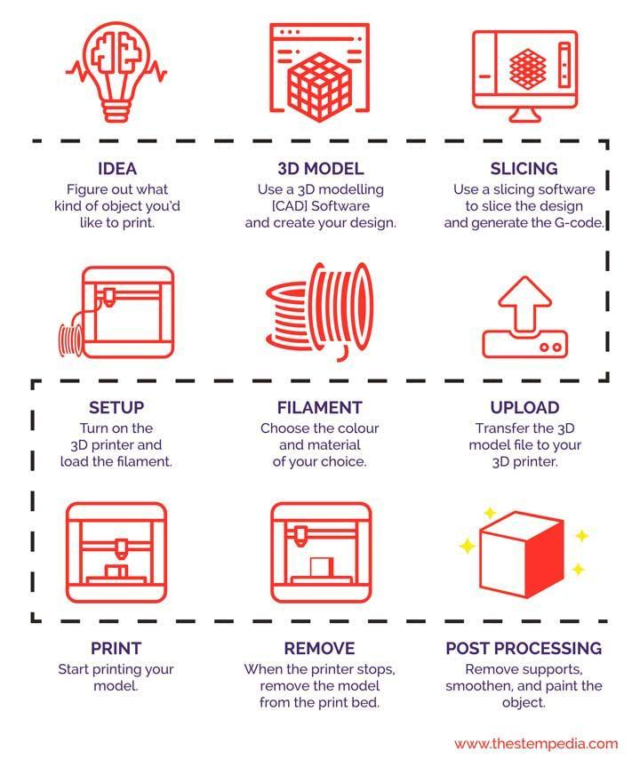  Figure 10: 3D Printing pipeline Image source: https://thestempedia.com/tutorials/getting-started-with-3d-printing/ | 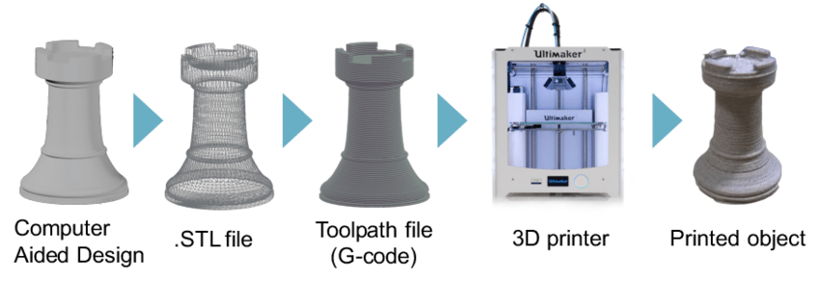  Figure 11: 3D Printing process Image source: https://www.researchgate.net/figure/3D-printing-process-chain_fig2_327760995

3.2 The 3D technologies
There are several 3D Printing technologies but seven are the most common ones:
- Sheet lamination also called laminated object manufacturing (LOM), is a rapid prototyping process in which sheets of material are placed together to create an object. It is commonly used for building strong 3D objects with complex geometries.
- Binder jetting, also known as drop-on-power printing, is a 3D Printing process that creates solid objects using a 3D CAD file. It works with various materials, including ceramics, composites, sand, and plastics. In binder jetting, the process uses a modified version of the inkjet printing process, therefore not requiring a heat source to bind the materials.
- Material jetting is a full-color additive manufacturing technique in which droplets of thermoplastic are selectively deposited using drop-on-demand (DOD) technology, like how an inkjet printer dispenses individual ink drops only when needed.
- Directed energy deposition (DED) is an additive manufacturing process that uses a heat source, such as a laser or electron beam, to melt metal powder or wire. It is commonly used to repair or add additional features to existing parts.
- Powder bed fusion (PBF) is an additive manufacturing technology that uses a heat source, such as an electron or laser beam, to melt and join material powder to create three-dimensional objects. This technique can be used to create both plastic and metal parts.
- Vat polymerization is an additive manufacturing process that uses a vat, or container, filled with photosensitive liquid resin and a light source to create solid objects. The build platform lowers from the top of the tank filled with liquid polymer. An ultraviolet light source selectively cures liquid resin according to the pattern defined in the 3D CAD data file. Upon contact with the light source, the photopolymer undergoes a chemical reaction and solidifies. This process is known as photopolymerization. Vat polymerization is a broad class encompassing several 3D Printing technologies, including stereolithography (SLA), digital light processing (DLP), and continuous liquid interface printing (CLIP).
Although the most used 3D Printing process is material extrusion. This technique requires a thermoplastic material which is pushed through a heated extrusion nozzle and deposited layer by layer to build an object. Fused filament fabrication (FFF), also referred as fused deposition modeling (FDM), is the most used additive material extrusion process. A heated extrusion head precisely lays thermoplastic material over the print. Then the printing bed lowers, and the next layer of material is applied. The completed object can be removed from the print bed, as well as any supports. Freshly printed FDM parts have visible layer lines, so post-processing may be required to produce a smooth surface finish. Industrial-grade materials such as ABS and PLA are commonly used for FDM due to their high heat resistance and excellent strength-to-weight ratio. (The 7 Types of Additive Manufacturing, n.d.)

3.3 3D Printing materials
An essential aspect of 3D Printing is the material and, consequently, the 3D printer that will be chosen for the creation of the object. For instance, some 3D Printing processes use materials (such as plastic, ceramic, and metal) which utilize a heat/ light source to melt/ sinter/fuse layers of the material together in the defined shape. Unlike polymer resin materials that use a light/laser to solidify the resin in thin layers. In 3D Printing, dropping fine droplets is similar to 2D inkjet printing but includes superior materials to ink and a binder to hold the layers together. A standard and easily recognized process is deposition, employed by several 3D printers. This process extrudes plastic, commonly ABS PLA or, in filament form, using a heated extruder to create layers and form the predetermined shape. Considering that parts can be directly printed, it is possible to produce detailed and intricate objects, often with built-in functionalities and negating the need for assembly.
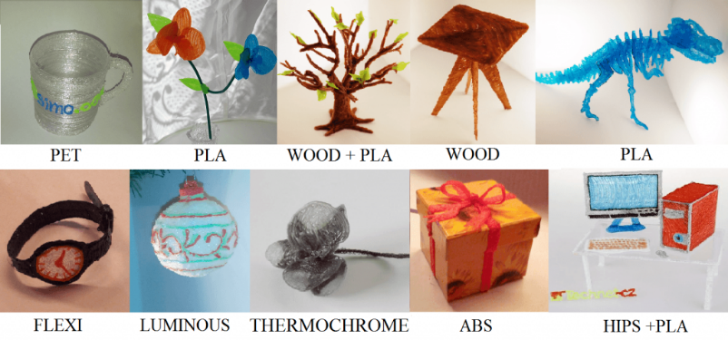
Figure 12: 3D printing materials Image source: https://blogs.truventor.ai/blogs/3d-printing-materials-used/
Choosing the proper material depends on what printer will be used as well as the desirable texture of the final object. The traits can be tensile strength, ductility, etc. One of the most critical traits of them all is flexibility. What flexibility does is that it adds strength to the product and increases its durability. These are just a few commonly used materials for 3D Printing. As previously established, the type of material depends on the product to manufacture. In the case of bio printing, the materials will be cells or body tissues. Some printers work with sugar, pasta, and meat. The food industry is using 3D printing technology by experimenting with food substitutes. (WHAT MATERIALS ARE USED FOR 3D PRINTING? n.d.)

3.3.1 Powders
Today’s more state-of-the-art 3D printers use powdered materials to construct products. Inside the printer, the powder is melted and distributed in layers until the desired thickness, texture and patterns are created. The powders can come from various sources and materials, but the most common are:
Polyamide (Nylon): With its strength and flexibility, polyamide allows for high levels of detail on a 3D-printed product. The material is especially suited for joining pieces and interlocking parts in a 3D-printed model. Polyamide is used to print everything from fasteners and handles to toy cars and figures.
Alumide: Comprised of a mix of polyamide and gray aluminum, alumide powder makes for some of the strongest 3D-printed models. Recognized by its grainy and sandy appearance, the powder is reliable for industrial models and prototypes.
In powder form, materials like steel, copper and other types of metal are easier to transport and mold into desired shapes. As with the various types of plastic used in 3D printing, metal powder must be heated to the point where it can be distributed layer-by-layer to form a completed shape.

3.3.2 Resins
One of the most limiting and therefore less-used materials in 3D Printing is resin. Compared to other 3D-applicable materials, resin offers limited flexibility and strength. Made of liquid polymer, resin reaches its end state with exposure to UV light. Resin is generally found in black, white and transparent varieties, but certain printed items have also been produced in orange, red, blue and green. The material comes in the following three categories:
- High-detail resins: Generally used for small models that require intricate detail. For example, four-inch figurines with complex wardrobe and facial details are often printed with this grade of resin.
- Paintable resin: Sometimes used in smooth-surface 3D prints, resins in this class are noted for their aesthetic appeal. Figurines with rendered facial details, such as fairies, are often made of paintable resin.
- Transparent resin: This is the strongest class of resin and therefore the most suitable for a range of 3D-printed products. Often used for models that must be smοother to the touch and transparent in appearance. (WHAT MATERIALS ARE USED FOR 3D PRINTING? n.d.)

3.3.3 Plastic
Plastic is a material made of synthetic or semi-synthetic compounds that has the property of being malleable (changing its shape). Most plastics on the market are completely synthetic (commonly derived from petrochemicals). However, given the growing environmental concern, plastics derived from renewable materials such as Polylactic Acid (PLA) are also popular. Due to their low cost, ease of manufacture, versatility and water resistance, plastics are used in a multitude of products and sectors. In 3D printing plastics are also very popular. (Alexandrea, 2020). The most popular 3D Printing plastics are PLA, ABS, PVA and PC.

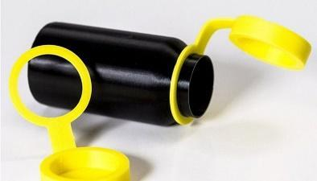 | 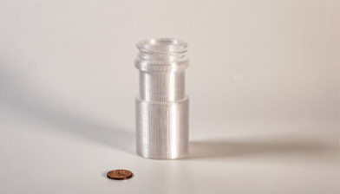 | 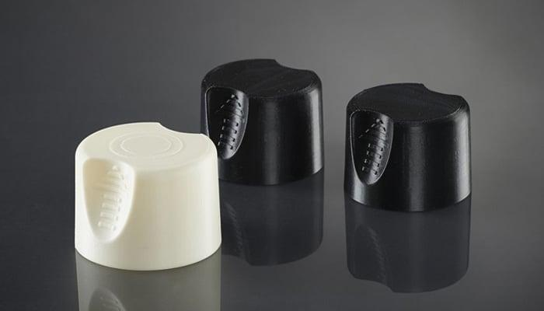
Figure 13: Plastic material, Image source: https://www.3dnatives.com/en/plastics-used-3d-printing110420174/
Polylactic acid (PLA) is one of the eco-friendliest options for 3D printers and is sourced from natural products like sugar cane and corn starch and is therefore biodegradable. It is available in soft and hard forms. Hard PLA is the strongest and therefore more ideal material for a broader range of products.
Acrylonitrile butadiene styrene (ABS): Valued for its strength and safety, ABS is a popular option for home-based 3D printers. Alternately referred to as “LEGO plastic,” the material consists of pasta-like filaments that give ABS its firmness and flexibility. ABS is available in various colors that make the material suitable for products like toys. Increasingly popular among craftspeople, ABC is also used to make jewelry and vases.
Polyvinyl Alcohol Plastic (PVA): Used in low-end home printers, PVA is a suitable plastic for support materials of the dissolvable variety. Though not suitable for products that require high strength, PVA can be a low-cost option for temporary-use items.
Polycarbonate (PC): Less frequently used than the plastic types, polycarbonate only works in 3D printers that feature nozzle designs and that operate at high temperatures. Among other things, polycarbonate is used to make low-cost plastic fasteners and molding trays.
Plastic items made in 3D printers come in a variety of shapes and consistencies, from flat and round to grooved and meshed. A quick search of Google images will show a novel range of 3D-printed plastic products such as mesh bracelets, cog wheels and Incredible Hulk action figures. For the home craftsperson, polycarbonate spools can now be purchased in bright colors at most supply stores. (WHAT MATERIALS ARE USED FOR 3D PRINTING? n.d.)

3.3.4 Ceramic
Ceramic materials have properties that are valuable in both high-tech manufacturing and art. 3D Printing create parts with shapes not possible with other process, and at the same time is more cost effective and faster than producing ceramic parts in the traditional way particularly for industrial applications. 3D Printing ceramics inspired artists, sculptors, and architects attracted to detail. 3D printers have been used in recent years to extrude terracotta to create roof tiles, artificial reefs, building facades, and even entire buildings. The terms ceramic and clay are often used interchangeably to describe different materials for making pottery. Nevertheless, not all ceramics are made of clay. Clay is a natural material that comes from the ground, and ceramics are various materials that harden when heated. When it comes to 3D Printing, a wide range of clay material, including terracotta, Kaolin and porcelain can be extruded through a nozzle to produce final shapes. (The Best Ceramic 3D Printers of 2022, 2022)

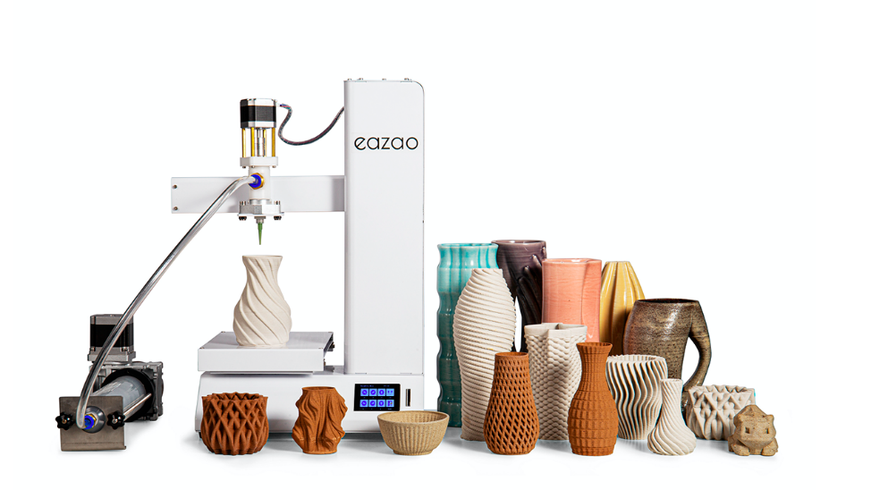
Figure 14: Ceramic Image source: https://www.eazao.com/

3.3.5 Metal
Very popular material in the 3D Printing industry is also metal, which is used through direct metal laser sintering or DMLS. DMLS printers has been embraced among others by manufacturers of air-travel equipment and makers of jewelry products, which can be produced much faster and in larger quantities — all without the long hours of painstakingly detailed work — with 3D Printing. Metal can produce a stronger and arguably more diverse array of everyday items. Jewelers have used steel and copper to produce engraved bracelets on 3D printers. One of the main advantages of this process is that the engraving work is handled by the printer. As such, bracelets can be finished by the box-load in just a few mechanically programmed steps that do not involve the hands-on labor that engraving work once required. The range of metals that are applicable to the DMLS technique diverse. Some examples are stainless-steel, bronze, gold, nickel, aluminum, and titanium. In the printing process, metal is utilized in dust form. The metal dust is fired to attain its hardness. This allows printers to bypass casting and make direct use of metal dust in the formation of metal parts. Once the printing has completed, these parts can then be electro-polished and released to the market. Metal dust is most often used to print prototypes of metal instruments, complete, marketable products such as jewelry, medical devices and more. (WHAT MATERIALS ARE USED FOR 3D PRINTING? n.d.)

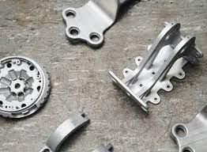  Figure 15: Metal parts, Image source: https://www.hubs.com/knowledge-base/introduction-metal-3d-printing | 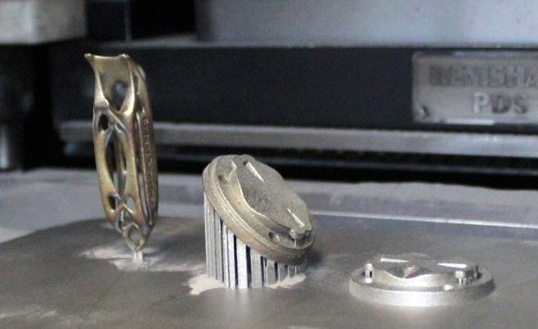  Figure 16: Metal 3D printing, Image source: https://www.assemblymag.com/gdpr-policy?url=https%3A%2F%2Fwww.assemblymag.com%2Farticles%2F94886-innovations-in-metal-3d-printing
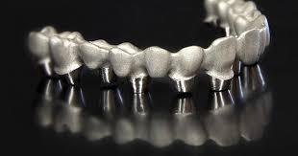  Figure 17: Metal- medical parts, Image source: https://www.3dsystems.com/learning-center/case-studies/direct-metal-3d-printing-brings-growth-benefits-microdent-dental-lab | 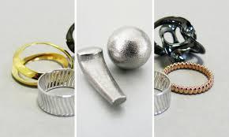  Figure 18: Metal 3D printing - Jewelry, Image source: https://www.sculpteo.com/blog/2018/07/23/3d-printing-materials-which-metal-should-you-choose-for-your-project/

3.3.6 New materials
Additionally, alternative 3D printer filaments exist, some of which are hybrid materials. A robust looking filament is sandstone. This kind of filament is basically made up of PLA with Brick mixed into it, it can be in form of a fine chalk powder or similar to provide a stone-like color and texture to it. Magnetic 3D printer filament has magnets. It is often created through the use of iron powder being mixed into a PLA filament. Wood based filaments are often made up of recycled wood but can range from cork that otherwise have 80% of its use going to wine bottle corks, bamboo a plant of fast growth and dry stems, wood dust and much more. The wood fibers can be mixed in with various bases such as PLA/PHA and more as a hybrid filament. Fluorescent 3D printer filament glows in the dark (J., 2020).
Food can also be a 3D Printing material. 3D Printing food mostly works like printing filament with a regular FDM 3D printer, in the sense that material is deposited onto a surface to create a final object. While there have been studies with other additive processes like binder jetting and SLS with powdered foodstuffs, it’s still debatable whether these processes are viable for food printing or not. (Carolo, 2021). Another 3D printing material yet challenging is glass. Despite the novelty of successfully 3D Printing molten glass, this method of 3D Printing has drawbacks such as particularly poor resolution. Artistic expressions such as vases and bowls may not suffer from lack of precision, but high-tech applications requiring precise microstructures will most likely do. (MCDONALD, 2019)

3.4 Applications of 3D Printing
3D Printing, also known as additive manufacturing, has come a long way since it was first developed in the 1980s. While 3D Printing originated as a tool for rapid prototyping, it has now evolved to cover several different technologies. The evolution of 3D Printing has seen rapid growth in the number of companies adopting the technology. The applications and use cases vary across industries but broadly include tooling aids, visual and functional prototypes — and even end-use parts. 3D Printing has gone through several changes over the years. In the early days, 3D Printing was time-consuming, costly, and not very practical for applications outside the industry. However, with today’s more flexible and cost-effective 3D Printing methods, the areas where 3D Printing has become a practical tool are increasing rapidly. In the image below there are given some of the fields that 3D printing is used.
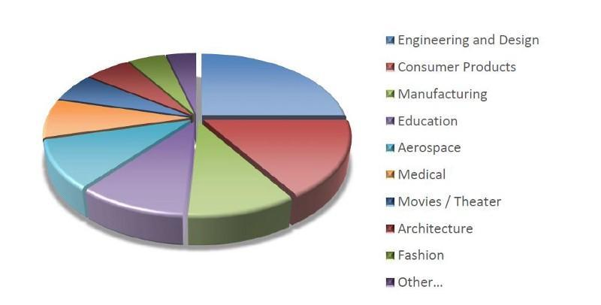
Figure 19: Applications of 3D printing, Image source: https://medium.com/autodesk-university/real-world-applications-of-3d-printing-388dcb210d6e
One of the most significant growth areas in 3D Printing is the replacement parts industry considering that parts can be printed on demand without storing them in a warehouse. Additionally, if a part is no longer manufactured, the replacement can be designed and printed fairly quickly, compared to other manufacturing processes. The replacement parts industry is undergoing tremendous change because of additive manufacturing. The aerospace and defense (A&D) industry is one of the earliest adopters of 3D Printing, with the first use of the technology going back to 1989. (Schain, 2015). While prototyping currently remains the main application of 3D Printing in the automotive industry, companies are increasingly finding other use cases, such as tooling. The benefits of 3D Printing for automotive are among others the faster product development, the design flexibility, the customization, the creation of complex geometries and the prototyping.
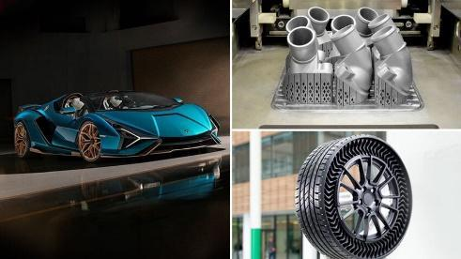
Figure 20: 3D printing in automotive, Image source: https://www.3dnatives.com/en/3d-printing-applications-in-automotive-ranking-081020204/
The medical and dental industry is one of the fastest-growing adopters of additive manufacturing. From medical devices to prosthetics and even bio printing, the applications of additive manufacturing for the medical industry are versatile and wide-ranging. The benefits of 3D Printing for Medical & Dental are enhancing medical devices and personalized healthcare.
3D Printing provides a cost-effective approach to product development, testing, and production. From consumer electronics to toys and sportswear, critical players within the consumer goods industry increasingly recognize 3D Printing as a valuable addition to existing manufacturing solutions. Additionally, the recent growth of industrial desktop 3D printers has brought the technology closer to the hands of designers and engineers, accelerating the opportunities of what can be achieved within the sector. 3D Printing for Consumer Goods offers enhanced product development, faster time-to-market, mass customization.
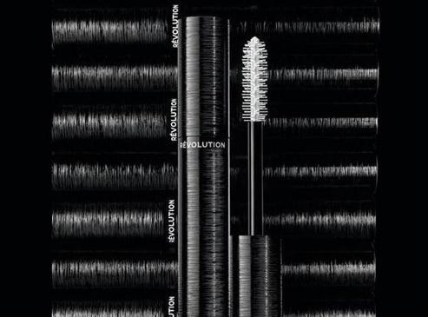

Figure 21: 3D printed mascara. Image source: https://www.independent.co.uk/life-style/fashion/chanel-launches-mascara-3d-printing-le-volume-revolution-beauty-a8397356.htm l
While 3D Printing has historically been seen as the sole preserve of industrial manufacturing, technology is also finding its way into the beauty industry. French fashion company Chanel is one company demonstrating the potential of 3D Printing, having launched the world’s first 3D-printed mascara brush in 2018. The Révolution Volume mascara brush was created using SLS, a technology that uses a laser beam to fuse layers of polyamide powder. With 3D Printing, the design of the brush has been optimized - for example, the rough, granular texture improves the mascara's adhesion to the lashes.
3D Printing benefits jewelry makers in two ways. The first is by 3D Printing investment casting patterns, which are cheaper and faster to produce than traditional methods. A second approach is to 3D print jewelry directly using precious metals. Both ways enable custom jewelry with thin walls and intricate details to be created, which would be impossible to make through other means. The technology featured various shapes, including a star, cloud, and flower, making it easier to reach unprecedented levels of customization and highly complex designs. The customizable nature of the collection means that customers can choose from various combinations and variations.
The industrial goods sector includes machinery components, tooling, and equipment used to manufacture other goods. With increasing production costs and the digitization of manufacturing, industrial OEMs must constantly evolve to maintain operational agility and keep costs down. Manufacturers are increasingly turning to 3D Printing to stay agile, responsive, and innovative. Some key benefits of 3D Printing for Industrial Goods are the design complexity, the shorter lead times, the on-demand production, and tooling. (Industrial Applications of 3D Printing, 2021)
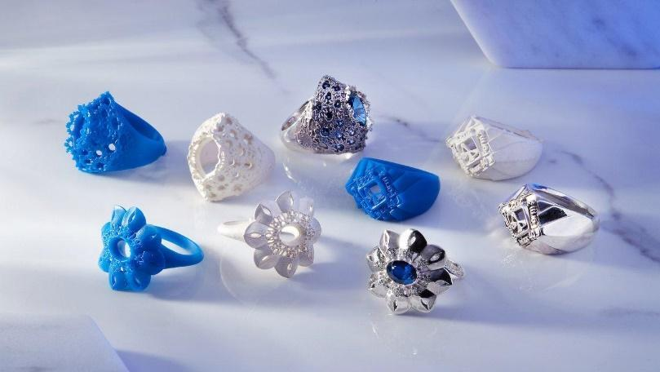

Figure 22: 3D printing jewelry, Image source: https://formlabs.com/blog/3d-printed-jewelry
The world of 3D Printing is expanding, and printers become more affordable which places them in homes, online stores and even supermarkets offering 3D Printing services. The result might be in some cases wonderful or even weird 3D printed objects. People can download or design files and print them. In 2014, designer Deniz Karasahin created the concept of a new cast for broken limbs that helps the healing process. The 3D printed cast included a low-intensity pulsed ultrasound system that was designed to help damaged bones to heal faster - approximately 38 percent faster.
Foodini is a 3D food printer capable of printing an entire pizza. This printer, designed by Natural Machines can produce other kinds of food as well, such as burgers, spaghetti and more.
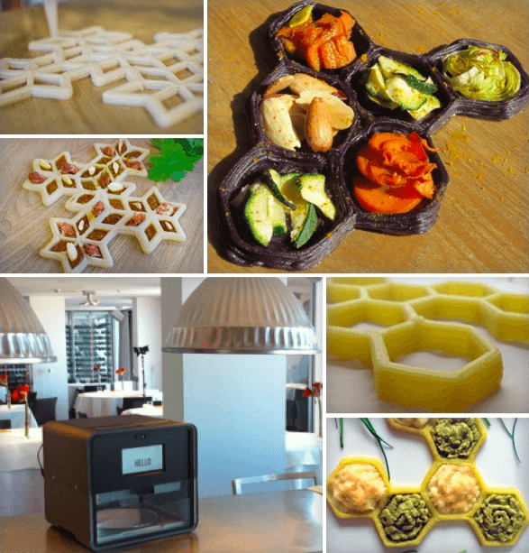

Figure 23: Foodini, 3D printer https://www.sculpteo.com/blog/2014/04/02/the-foodini-3d-food-printer/

There have been various advancements in the bio-printing space over the last few years, including research into 3D Printing for tissue repair and reconstruction, limb replacement, kidney transplants and heart transplant.
In 2013 3Dvarius made a move to Kickstarter with the promise of a 3D-printed violin that was designed to create a symbiosis between itself and the musician. Precision, an innovative design and an eye for detail turned 3Dvarius from a concept into a fully functioning musical instrument that really stands out from the crowd.

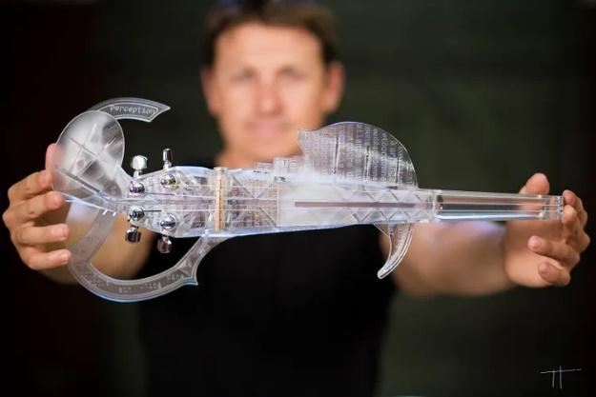

Figure 24: 3D printed violin https://plastics-themag.com/A-violin-called-3D-Varius/
Back in 2014, a private Chinese company known as WinSun crafted the first 3D printed house. Four large 3D printers were put to work to spray concrete layer-by-layer to construct the walls. This 3D Printing method seemed to be cheap, and the lack of manpower involved meant costs could be kept even lower. At the time it was stated that a house could be printed for less than $5,000.
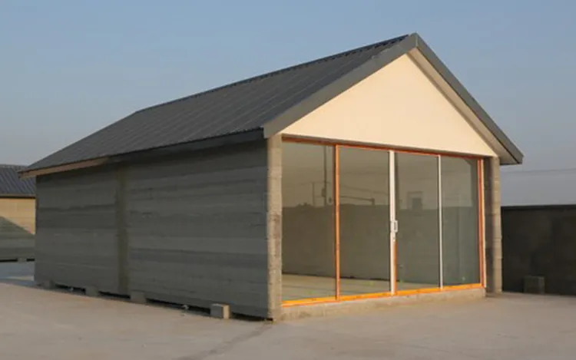
Figure 25: 3D printed house https://inhabitat.com/chinese-company-assembles-ten-3d-printed-concrete-houses-in-one-day-for-less-than-5000-each /
ChefJet Pro 3D is a 3D Printing device that is able to 3D print sweets and candy treats. The flavors ranging from chocolate to vanilla, mint, sour apple, cherry and watermelon.
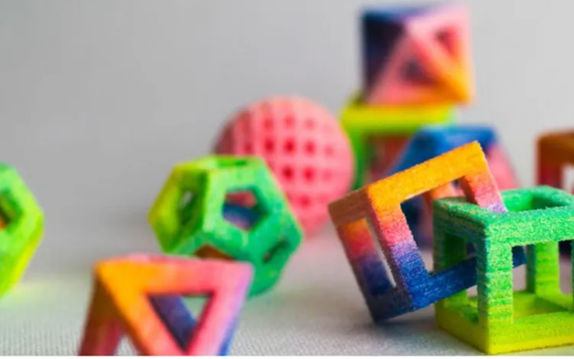
Figure 26: 3D printed candy https://www.dezeen.com/2014/01/09/first-food-3d-printer-launched-by-3d-systems-at-ces/

3.5 Benefits of 3D printing
3D Printing offers a wide range of advantages compared to traditional manufacturing methods. These advantages are related to design, time, and cost, amongst others.
- Flexible Design
3D Printing offers the opportunity to design and print more complex designs than traditional manufacturing processes. Traditional processes have design restrictions that do not longer apply with the use of 3D Printing.
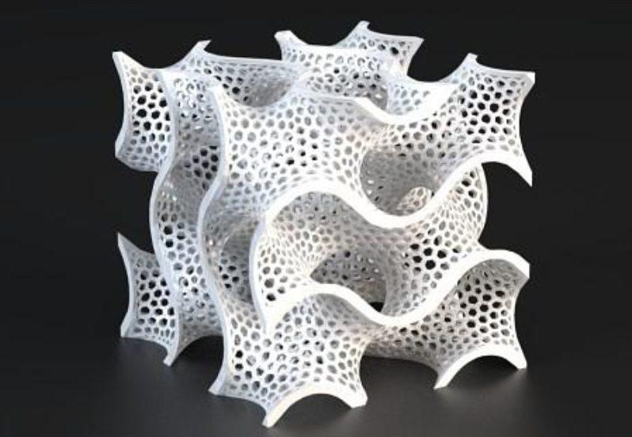
Figure 27: Complex design, Image source: https://amfg.ai/2018/06/14/designing-for-fdm-3d-printing-top-10-tips/
- Speed/ Rapid Prototyping
3D Printing can manufacture parts within hours, which speeds up the prototyping process. Compared to machining prototypes, 3D Printing is inexpensive and quicker at creating parts, allowing each design modification to be completed much more efficiently. With the ability to reduce the time of the prototyping phase, businesses can deliver better, improved, and enhanced products in a shorter time. Giving a competitive advantage over the competition. However, it also makes it possible to develop products early, creating prototypes more frequently until the product is perfected and ready for production, creating a highly effective product launch. (Advantages of 3D Printing, n.d.)
- Print on Demand
Printing on demand is another advantage as it only needs a little space to stock inventory, unlike traditional manufacturing processes. This saves space and costs as there is no need to print in bulk unless required. 3D design files can be stored in virtual libraries as they are printed using a 3D model using either a CAD or STL file and, therefore, can be printed when needed. Edits to designs can be made at meager costs by editing individual files without wastage of out-of-date inventory and investing in tools.
- Strong and Lightweight Parts
One of the most used materials is plastic, although some metals can also be used for 3D Printing. However, plastics offer multiple advantages as they are lighter than their metal equivalents. This is particularly important in industries such as automotive and aerospace, where lightweight is an issue and can deliver greater fuel efficiency.

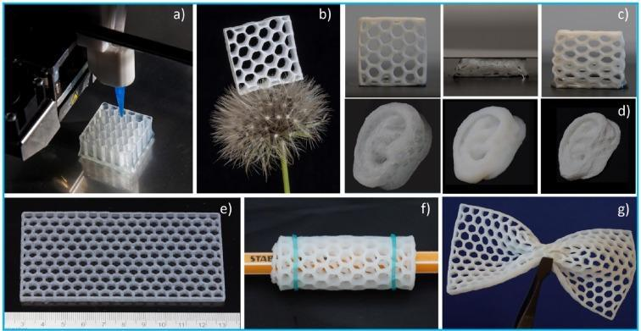

Figure 28: Strong and lightweight objects, Image source: https://www.sciencedirect.com/science/article/pii/S1385894720327960

Additionally, parts can be created from tailored materials to provide specific properties such as heat resistance, higher strength, or water repellency.
- Minimizing Waste
The production of parts only requires the materials needed for the part itself, with little or no wastage compared to alternative methods, which are cut from large chunks of non-recyclable materials. Not only does the process save on resources, but it also reduces the cost of the materials being used.
- Cost Effective
3D Printing is a single-step manufacturing process that saves time and costs associated with using different machines. 3D printers can be set up and left to get on with the job, meaning that there is no need for operators to be present the entire time.

3.6 Limitations of 3D Printing
3D Printing also bares some limitations, as listed below:
- Limited Materials
While 3D Printing can create items in a selection of plastics and metals, the available selection of raw materials is not exhaustive due to the fact that not all metals or plastics can be temperature controlled enough to allow 3D Printing.
- Restricted Build Size
3D printers currently have small print chambers which restrict the size of parts that can be printed. Anything more significant must be printed in separate parts and joined together after production. This can increase costs and time for more significant parts due to the printer needing to print more parts before manual labor is used to join the parts together.

- Post Processing
Although large parts require post-processing, as mentioned above, most 3D printed parts need some form of cleaning up to remove support material from the build and to smooth the surface to achieve the required finish. Post-processing methods include water jetting, sanding, a chemical soak and rinse, air or heat drying, assembly, and others.
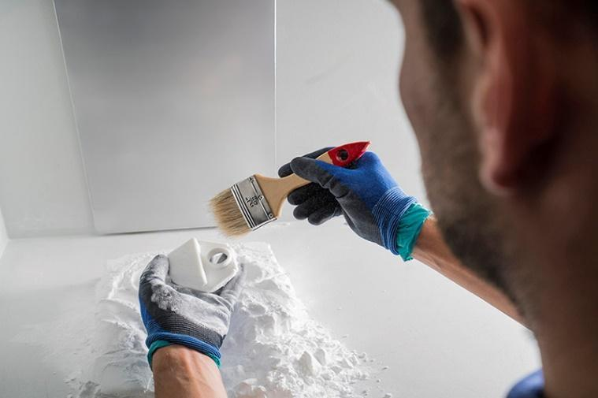
Figure 29: Post processing, Image source: https://www.beamler.com/post-processing-3d-printing/
The amount of post-processing required depends on factors including the size of the part being produced, the intended application and the type of 3D printing technology used for production.
- Large Volumes
3D Printing is a static cost unlike more conventional techniques like injection molding, where large volumes may be more cost-effective to produce.
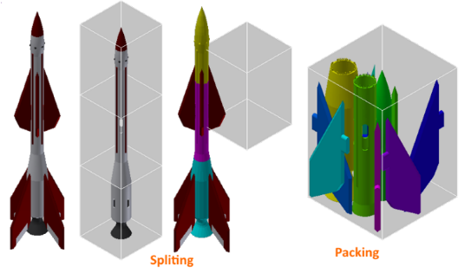
Figure 30: 3D Printing in parts, Image source: https://3dprint.com/10391/3dprinttech-3d-print-large-objects/
While the initial investment for 3D Printing may be lower than other manufacturing methods, once scaled up to produce large volumes for mass production, the cost per unit does not reduce as it would with injection molding.

- Spare parts
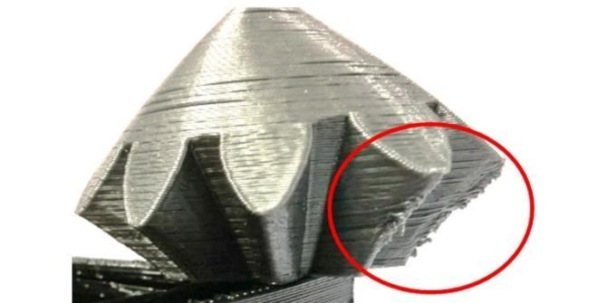
Figure 31: 3D print complex shapes, Image source: https://cults3d.com/en/blog/articles/identify-correct-3D-printing-problems-defaults
With 3D Printing, parts are produced layer by layer. Although these layers adhere together, they can delaminate under specific stresses or orientations. This problem is more significant when producing items using fused deposition modeling (FDM), while polyjet and multijet parts also tend to be more brittle. (WHAT ARE THE ADVANTAGES AND DISADVANTAGES OF 3D PRINTING? n.d.)

3.7 3D Printing in education
As professionals across almost every industry—healthcare, aerospace, engineering, manufacturing, and entertainment—continue to increase investment in 3D Printing, technology becomes part of daily life. The benefits of 3D Printing in education include improved student engagement and collaboration, workforce development, multidisciplinary thinking patterns and empowered creativity. 3D Printing ensures that each student has access to the hands-on tools they need and gives teachers the power to change those tools or print extra if necessary. These types of in-person interactions are invaluable for developing young adults.
From primary schools to post-graduate college programs, 3D Printing is a way for educators to encourage more active participation in the learning process. 3D Printing allows students to truly connect to the subject matter by physically manipulating ready-printed teaching aids or by designing tools themselves. For K-12 students, this hands-on aspect of 3D printing in the classroom helps improve engagement and participation. (Guide to 3D Printing in Education, n.d.) The emergence of 3D Printing technologies is introducing industrial skills deficits and opportunities for new teaching practices in various subjects and educational settings. The most common application of 3D Printing in schools, universities, libraries and unique education settings is listed below:
- Teach students about 3D Printing
- Teach educators about 3D Printing
- Supportive technology during teaching
- Produce artefacts that aid learning
- Create assistive technologies
- Support outreach activities (Ford & Minshall, 2018)
3D Printing can be implemented in education by assisting in the learning process of several subjects such as mathematics, physics, biology, history and more. Mathematics impacts almost every aspect of daily lives, and therefore is a core STEAM subject. However, a difficulty faced in teaching mathematics is presenting abstract mathematical concepts and ideas to students in an engaging way. Bringing on board 3D Printing, teachers can easily explain mathematical concepts in an effective way, stimulating the interest. Through visualization and observation, 3D Printing allows both teacher and students to gain fresh insight and depth to their learning.
Hands-on learning leads to a deeper understanding and an inspired classroom. Helping students to further develop important skills like design thinking, problem solving and critical analysis. (Heiss, 2020)
As mentioned, 3D printers for schools are quickly making headway in classrooms across the world, integrating with various subjects in many unique ways. The applications are diverse, and the impact far reaching. Among the many other benefits, the significant integration with progressive learning methods ensures that 3D printers are rapidly becoming a vital classroom fixture. For example, in biology education 3D printed life-sized models of organs, can be used allowing students to examine and study cross-sectional areas of lungs, hearts, and brains. Biomechanics of an insect could be recreated, allowing the examination of the nuances of fossilized bone structures, develop new ways to represent human cells and organs, or even mimic the internal structures of rare plant species to demonstrate the process of photosynthesis.
3D Printing seems to be redefining the learning curriculum, saving money, and providing new angles for teaching that before seemed impractical. 3D printers add new tools to the learning curriculum while replacing or enhancing older, traditional methods. For example, instead of viewing the details of a protein under a microscope, large display example could be printed for the classroom.
Some years ago, Glacier Peak High School in Snohomish, WA acquired an industrial grade 3D printer for a variety of school subjects including Biology. The opportunity was given to print large scale models of proteins for presentation, to represent various portions of its structure in different colors and allowed students to highlight “active clefts”. From DNA fingerprints to molecular models of cancer, students were also developing biotechnology-oriented projects in conjunction with scientists from the Milwaukee School of Engineering. (3D Printers for Biology Education, n.d.).
The participants of the 3D4CE project are the research teams of both Quantitative Methods Laboratory and Waste Management Laboratory, the Privacy Engineering and Social Informatics Laboratory of the University of the Aegean, school teachers and representatives of the “2nd Primary School of Chios”, the “ISA13 Istituto Comprensivo Sarzana” (Italy) and the “Agrupamento de Escolas de Marrazes” (Portugal).

3.8 3D Printing in Cultural Heritage
As a means to reconstruct lost historical sites and give new meanings to heritage, technology has become a unique point of encounter between past and present. Over the last years, digitization of European cultural heritage has been a dominant trend that yielded a number of projects enabling new interpretations of history, arts and culture, while 3D Printing and remodeling reached new heights to provide more sophisticated and cost-effective ways to reconstruct historic objects and places. (Team, 2016)
3D Printing if seconded by a paradigm change to the museum model, can be employed in many ways to reintegrate touch and other non-retinal senses into the cultural experiences. These multi-sensorial forms of experiencing culture also have a great benefit for the accessibility of cultural heritage, especially for people with learning difficulties, for children, the elderly, for blind or visually impaired visitors. 3D Printing is in a phase of rapid technological changes and promises more enhancing experiences for the field of cultural heritage. This would provide a more holistic appreciation of the produced objects, but make it necessary to develop basic guidelines for 3D printed models. We expect that 3D Printing will not only become vital in the field of reconstruction of objects, but also for research, documentation, preservation and educational purposes, and it has the potential to serve these purposes in an accessible and all-inclusive way. (Neumüller, Reichinger, & Rist, 2014)
The last few years have seen continuous experimentation and incremental technical advances. In 2011, The Economist featured a 3D-printed Stradivarius violin on its front page, claiming that 3D printing "may have as profound an impact on the world as the coming of the factory did." 3D Printing, as mentioned in previous chapters, bare several limitations that need to be taken on board for its successful application in several sectors.
Over the last decade, museums and other cultural institutions have been "test beds" for 3D Printing. Given their fragility and historical importance, collection objects cannot be touched and are commonly exhibited to people behind enclosed glass displays. The traditional way of engaging with cultural heritage is through the glass. However, this is changing with the help of 3D Printing. Visitors can experience and touch the exhibits without harming the original artifact.
Meanwhile, the American Museum of Natural History has asked students to digitize, print, and assemble dinosaur bones and identify species as paleontologists do, and the MediaLab of the Metropolitan Museum of Art in New York has created edible replicas of museum artifacts from ingredients like chocolate, cheese and rice for visitors to enjoy through taste. 3D Printing offers the opportunity to learn, enjoy and better appreciate cultural heritage through multi-sensory experiences.
Copies of museum objects to touch have been made for centuries using traditional methods. Nevertheless, the material aspect of objects has a crucial role in our ability to perceive and understand the world through meaningful experiences. Being able to touch, explore the shape, feel the weight and even smell an artifact's replica can transform cultural heritage experiences. What is new about digitally-fabricated replicas is that they can be highly accurate concerning the shape of the original. The power of digitally fabricated replicas also lies in their digital nature. This means they can easily be stored, edited and shared worldwide.
People interested in cultural heritage can access these digital replicas, for example, from museum websites and print them at home or a nearby Fablab on a desktop 3D printer. Most importantly, these digital representations can also be easily manipulated or customized to satisfy different audience requirements under different interpretation scenarios.
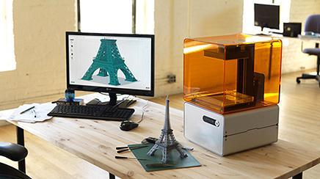
Figure 32: 3D replicas, Image source: https://www.prweek.com/article/1276330/brands-plan-bridge-physical-digital-worlds-3d-printing
3D Printing makes the creation of replicas for engaging diverse audiences of cultural institutions possible. For instance, visually impaired people can now experience custom-made replicas of objects to enhance their understanding of historical artifacts. In more detail, visually impaired people find complex forms more challenging to understand.
Further on, in January, Google’s Arts and Culture institute, the non-profit organization CyArk and the American 3D Printing manufacturer Stratasys announced an extended collaboration on the Open Heritage project. They aim to bring essential monuments and artifacts worldwide to life by physically producing small-scale versions of cultural heritage sites. (Samaroudi & Rodriguez Echavarria, 2019)
In archeology sector extensive destruction has taken its toll on history, but lately some archaeological sites that have been ravaged, looted, or eroded are getting a second chance through 3D Printing. Replicas of some of the most ancient artifacts or places in the planet can now be redone and therefore archaeologists are able to put together pieces that have puzzled them for centuries. These artificial substitutes are a great aid to let one reconstitute ruins. Examples of the archaeological uses for this technology are 3D printed replicas of skulls, such as the ones exhibited at the Brighton Museum & Art Gallery in the UK displaying facial reconstructions of the earliest British residents, the Google Arts and Culture collaboration with Stratasys to preserve 3D scans and 3D prints of some of the world’s most cherished heritage sites, facial reconstruction 3D images of Robert the Bruce, and the Uffizi Digitization Project, a website with 300 digitized objects from the Florence gallery’s Greek and Roman collection. Maamoun Abdulkarim, Director of Antiquities and Museums, in Syria, recalled that the safeguarding and protection of the remains of the past have gained a powerful tool, since 3D reconstruction of archaeological sites and finds will aid their conservation. In 2016, a replica of the 2,000-year-old Arch of Triumph of Palmyra, in Syria, was exhibited around the world. The replica was made by the Institute for Digital Archaeology (IDA) using 3D computer models based on photographs of the original arch, which was destroyed by ISIS in 2015.
Considering that 3D printers can already fabricate objects of almost any material and in any shape, the next step is a control over the behavior of materials, where they envisage voxel-based printing as ideal for archaeology. Especially since this allows the use of different types, shapes and sizes of voxels as programmable ‘smart’ digital materials that are designed to function in a desired way.
3D Printing has many advantages in archaeology considering that it allows the researchers to discover new clues in ancient grounds, print what they need on site without having to travel all over the world to find the piece they need, and, it allows museum visitors to handle a replica, turning the “Do Not Touch” sign into “Please, Go Ahead and Touch This”. Nevertheless, 3D printed models of archaeological artifacts or relics could also raise concerns and questions such as what happens to copyright laws. Would people rather see an original ancient relic or fossil in its damaged state or a perfectly 3D restored piece? If anyone can recreate an ancient artifact, will museums become “irrelevant”? Researchers argued that there is currently a lack of ethical and legal guidance regarding the use of 3D technologies in archeology and the standards that need to be implemented.

3.8 3D4CE Curriculum
The 3D4CE project aims to support students in developing the ability to research and invest in culture and knowledge and the transition to digital education through the use and familiarization of new digital technologies. The project's scope is to help raise awareness of the importance of European cultural heritage through education, learning, and participation of pupils in manufacturing 3D monuments using 3D Printing technology. Using 3D Printing, pupils can learn and create, on their own, various cultural heritage monuments from EU countries, thus contributing to the dissemination and promotion of culture among the collaborating institutions.
The aim of the Intellectual output 03 is to educate the teachers from the three participant countries, on using digital technologies to promote cultural monuments through primary education. During the training process, educational material was created. The material created regarding 3D Printing included the process of 3D Printing and the history of the technology. The material was created based on two types of audience, the teachers, and the students and in two main cores, theory, and practice. The theory around 3D Printing was extensively explained in order for the teachers to understand in depth the technology and be able to cover all the needs that the students might have. In addition, the benefits and limitations of 3D Printing were discussed taking into consideration equipment factors, material, purpose, and the properties of each object.
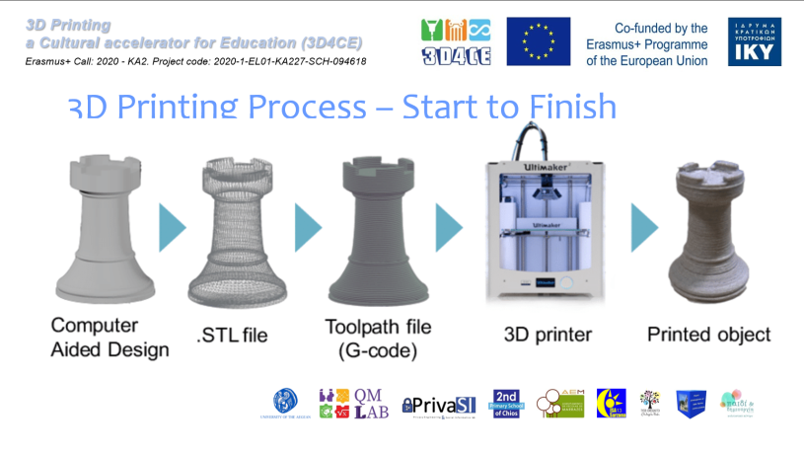 | 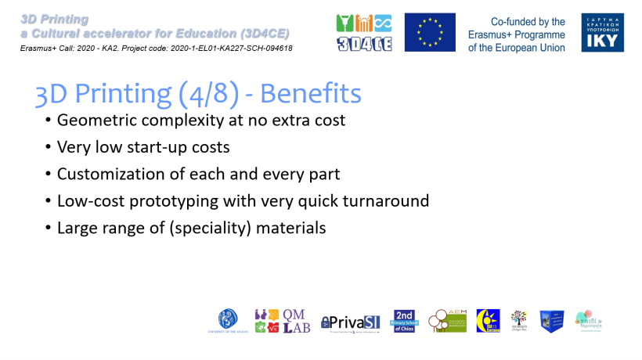
Figure 33: Parts of project’s presentation about 3D Printing processes
Important aspects of the 3D Printing process are the possible materials that can be used and the details regarding the 3D printers. The sectors of 3D Printing and the applications in each sector of the technology were discussed.
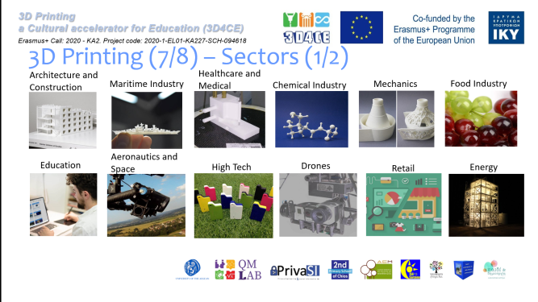 | 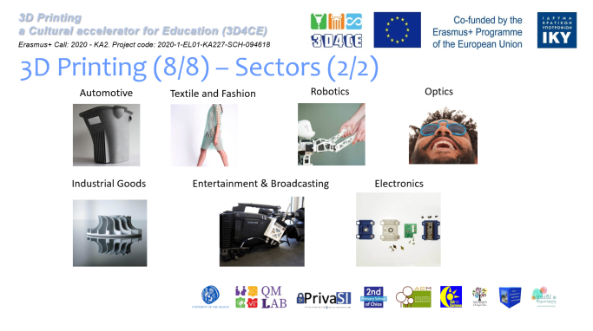
Figure 34: Parts of project’s presentation about 3D Printing processes

In order to accomplish a better understanding of the overall 3D Printing process the whole process and the limitations of 3D Printing where analyzed.
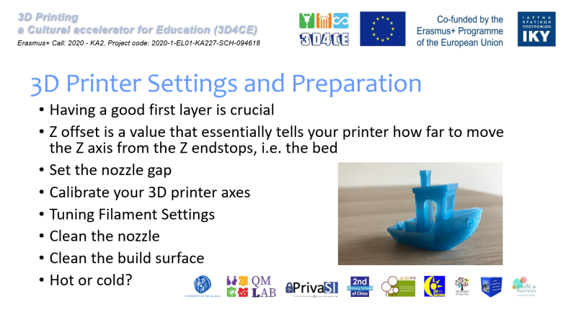 | 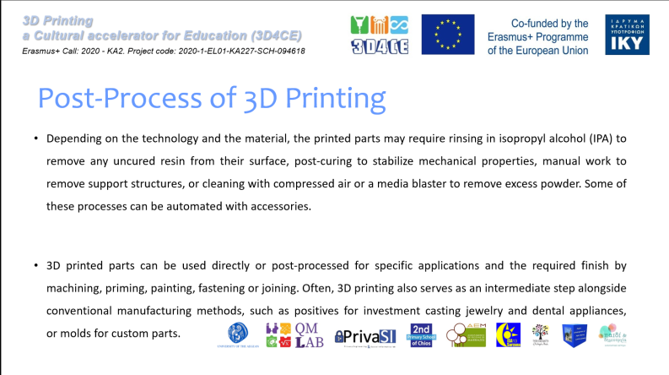
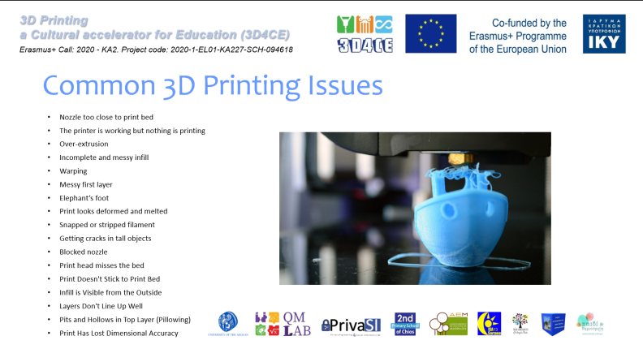 | 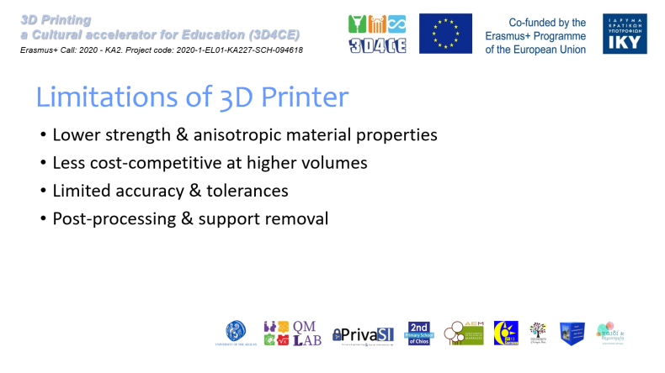
Figure 35: Parts of project’s presentation about 3D Printing processes
Further on, the technological applications in cultural Heritage were included in the curricula.
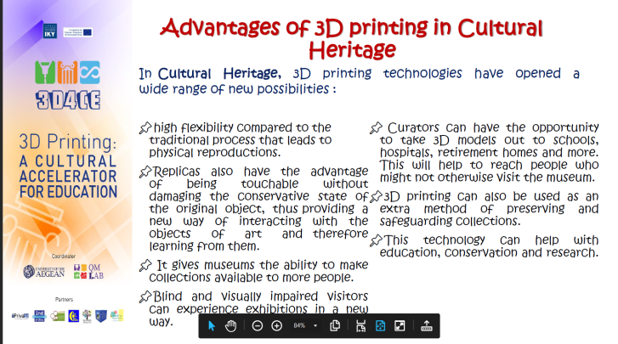 | 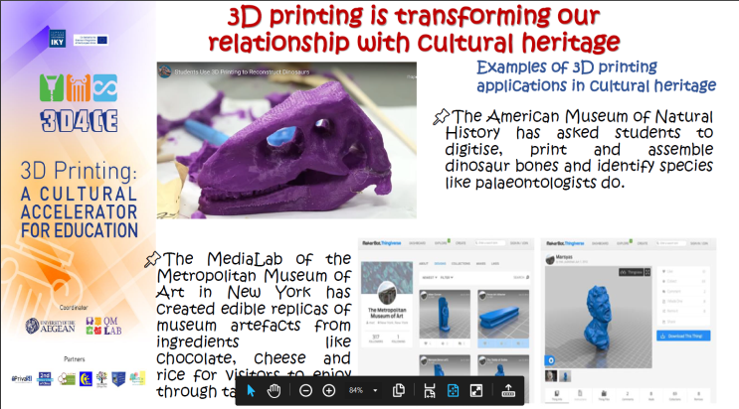
Figure 35: Parts of project’s presentation about 3D Printing processes

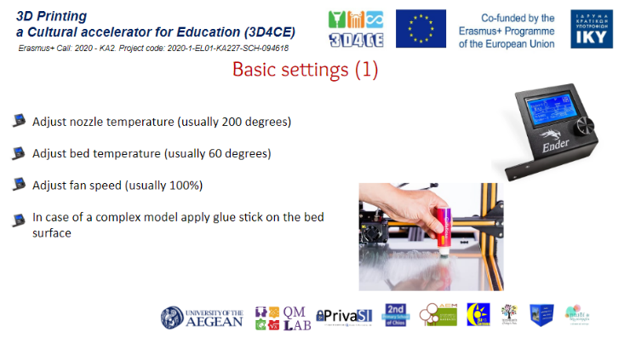
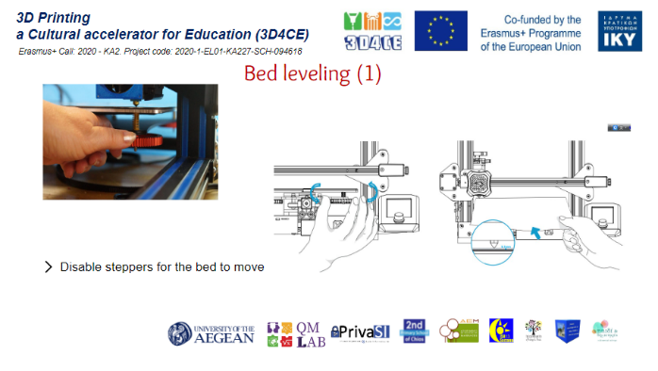
Figure 34: Parts of project’s presentation about 3D Printing processes (settings)
All the important steps of 3D Printing were explained, discussed, and applied such as bed leveling, printer settings, the slicer software, and post processing when necessary.
Several activities were done from the students assisted by their teachers. The students got introduced to 3D Printing and 3d printers while they had the opportunity to get to know several aspects of the cultural heritage through several types of activities including crafts, dance, music, and of course 3D Printing.

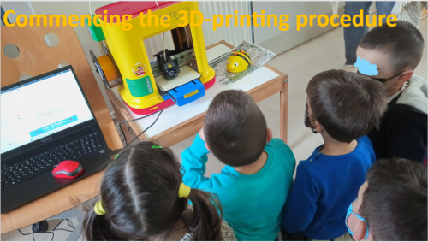 | 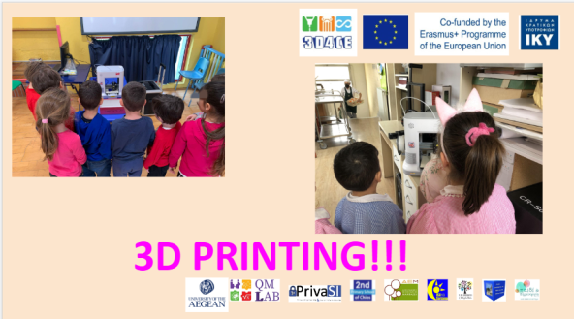 | 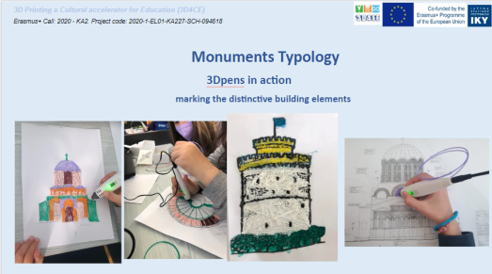
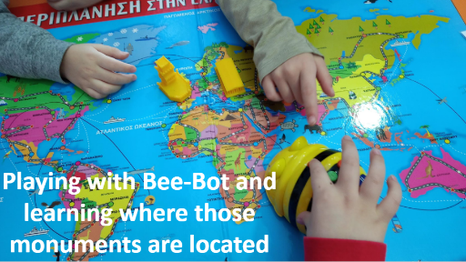 | 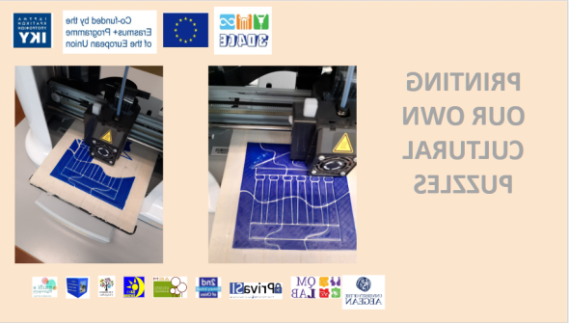 | 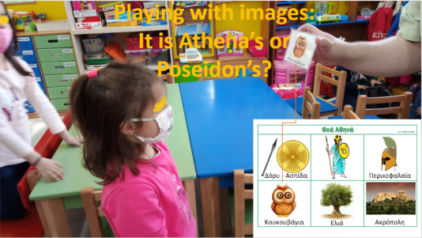
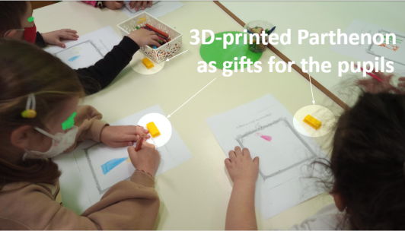 | 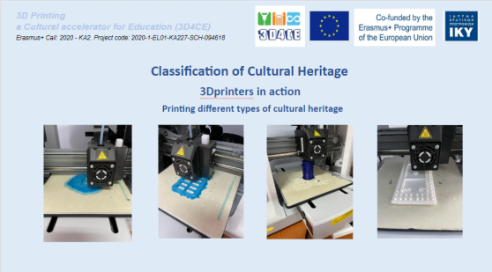 | 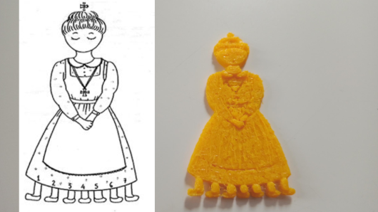
Figure 35: Activities developed for the 3D4CE project
Questionnaires were created and distributed, addressed to the teachers and the pupils aiming in evaluating the results of the activities and the overall experience of the project and whether the initial goals were achieved.
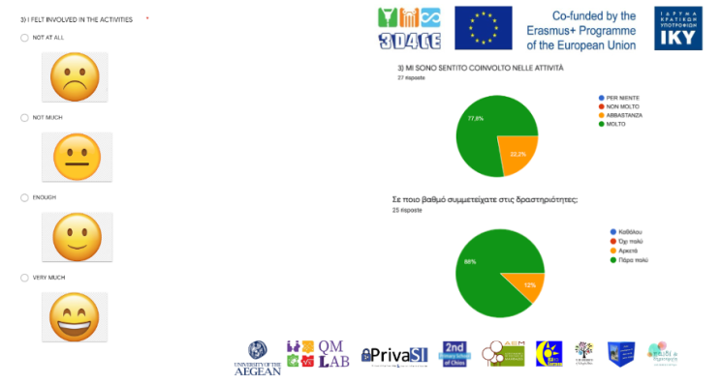 | 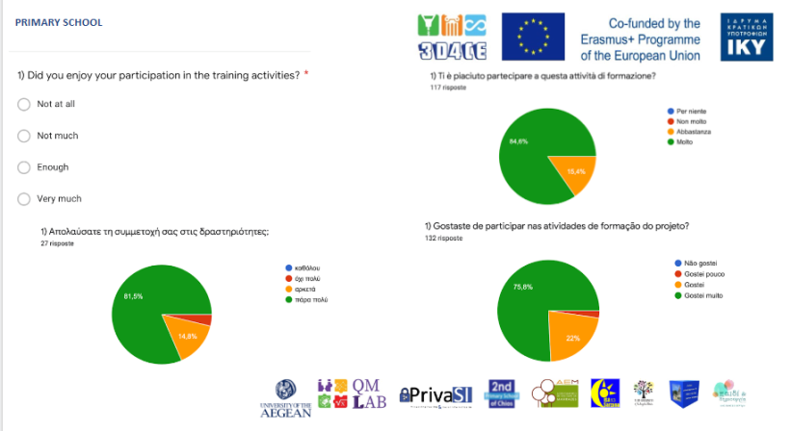
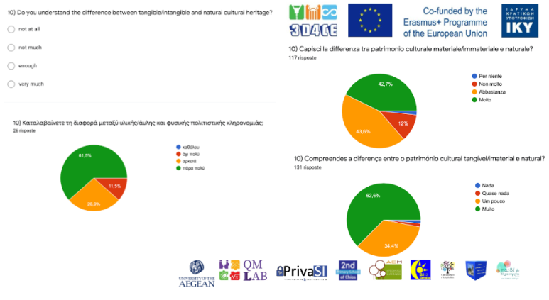 | 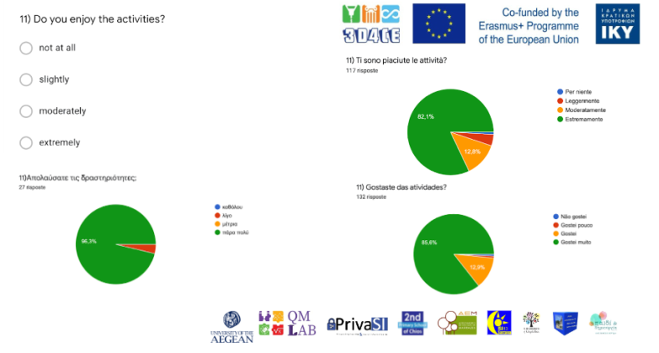
Figure 36: Evaluation of the project

3.9 3D Printers
For the successful implementation of the 3D4CE project, two types of 3D printers were used, the Creality Ender 3 pro and the XYZ printing Mini Maker. The Ender 3 Pro is an affordable 3D printer and an excellent and affordable tool for makers, hobbyists, tinkerers, and educated beginners. Ender 3 Pro is capable of delivering astonishing quality prints. The Ender 3 Pro offers a build volume of 220 x 220 x 250mm, a magnetic bed, a power recovery mode, and a tight filament pathway that makes it easier to work with flexible materials. It is a highly affordable printer and easy to assemble. It has a compact design with decent print volume. The prints can be high-quality. Additionally, the printer is upgradeable. The tight filament path improves compatibility with flexible filaments. (Locker, 2020)

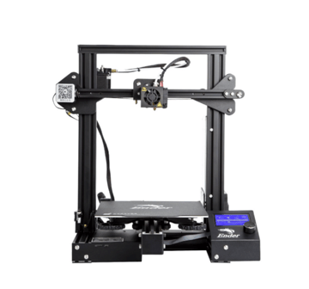
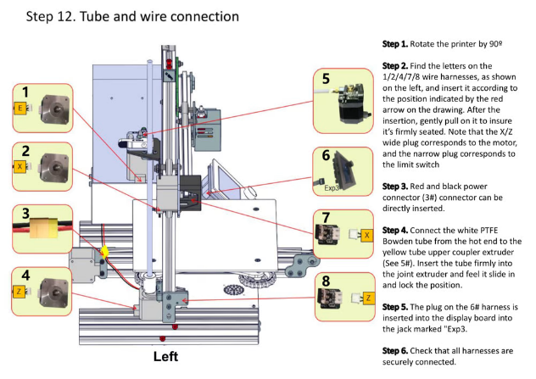
Figure 37: Creality Ender 3 Pro, Image source: https://all3dp.com/1/creality-ender-3-pro-3d-printer-review/

The basic setting to use the printer is to adjust nozzle temperature (usually 200 degrees), adjust bed temperature (usually 60 degrees), and adjust fan speed (usually 100%).

In case of a complex model the application of glue stick on the bed surface might be required. To load filament, printer must reach the desirable temperature (usually 200-210 degrees for PLA). When it’s ready, the filament can be pushed into the tube, until it leaks to the bed surface.
Da Vinci miniMaker 3D Printer is a superb entry-level 3D printer that’s reliable and easy to use. Its support of a wide range of materials makes it ideal for making all types of creative prints, from household items to toys. The da Vinci miniMaker offers great versatility. With its open filament system, experiments can be done with third-party materials. Metallic and carbon PLA can also be printed with a simple upgrade to the Hardened Steel Nozzle. (da Vinci miniMaker 3D Printer, n.d.)
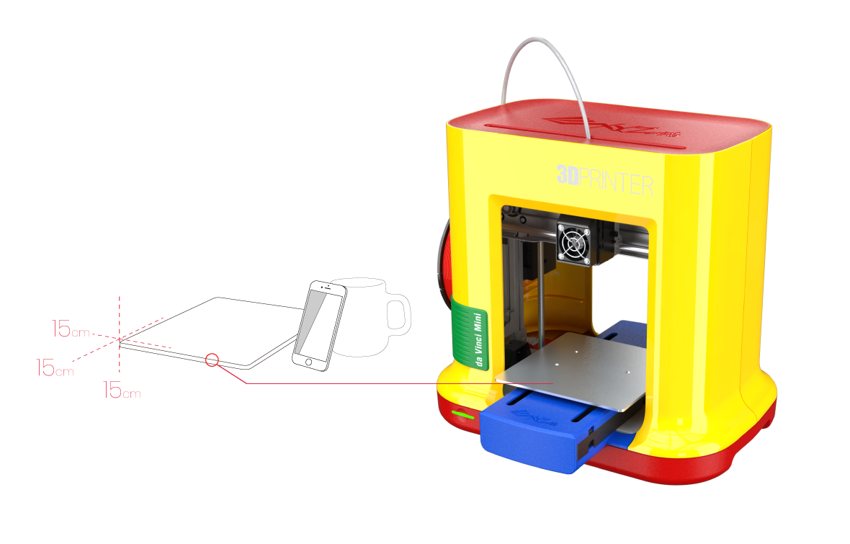
Figure 38: Da Vinci miniMaker 3D Printer, Image source: https://www.xyzprinting.com/en/product/da-vinci-minimaker
The XYZprinting da Vinci miniMaker is a child-proof printer with a protected nozzle, non-toxic filament, and a playful color scheme. This printer is targeted at children and young beginners and even comes with software tools to help teach 3D design, STEM education, and the overall 3D printing process. XYZprinting da Vinci miniMaker is Easy to use and at a low price. It is a Child-friendly 3D printer that is plug-and-play. It is quiet and offers autocalibration. It has free and easy-to-use resources: XYZware slicer, XYZmaker design software, tutorials, etc. (Koslow, 2017)

3D Scanning

4.1 3D Scanning methods
3D scanning is a process of analyzing a real-world object, aiming to collect its data (geometry, details, colors etc.) in order to recreate its shape and appearance. The object becomes a 3D model, which can be used as the base for a 3D project, 3D Printing, or can also be used to reconstruct, analyze, or simulate ideas. (How does 3D scanning work?, n.d.)

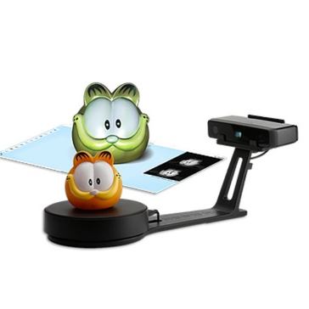
Figure 39: 3D scanner, Image source: https://www.3dhub.gr/shop/3d-scanners/einscan-se-3d-scanner/
The 3D scanner takes multiple snapshots of an object. The shots are then fused into a 3D model, an exact three-dimensional copy of the object, which can be rotated and view from different angles. A 3D scan is a three-dimensional image of part of an object’s surface. Sets of 3D scans form a 3D model. Just as 2D photos are made up of pixels, 3D scans are made up of tiny triangles, or polygons. Polygons form a polygonal mesh, which replicates the object’s geometry in minute detail. A 3D scanner generates 3D scans. A scanner works like a video camera, meaning it takes shots of an object. A camera, however, makes two-dimensional stills, while the scanner captures the geometry of the object’s surface. (Kivolya, 2019)

There are two types of 3D scanners to choose from, the stationery and the handled. A stationary 3D scanner is mounted to an arm or a tripod and is static at a location. The user rotates the object while the scanner captures multiple scans, and this process continues until all scans are captured of the entire object at different angles. Depending on the processing software, in some cases the scans can automatically be merged during the scanning process, or this might have to be done when all the scans are collected at the end. Individual scans are stitched together to create one complete digital model. For a handheld 3D scanner, the user hovers, and paints around the object to obtain 3D scan data of the entire object. It operates like a video camera, but it captures objects in 3D with continuous scanning.

Currently, a stationary 3D scanner compared to a handheld with the same technology (e.g., structured-light), stationary 3D scanners provide better accuracy and resolution. The scanner’s scan quality is influenced by the way it works. For example, stationary 3D scanners using structured-light technology take a series of images in one snapshot and consolidates the average to generate one scan. Handheld 3D scanners using structured-light technology take one shot per frame (equivalent to one scan) and then the user moves the scanner to take another scan. It’s similar to comparing a still image taken from a camera versus a frame taken from a video recording. The scan quality is still great for a handheld 3D scanner, but typically the stationary 3D scanner provides slightly better results when comparing scanners that are similar in price point.

However, it’s important to remember that several applications don’t require high quality and there are other factors such as portability and ease of use that might be more important. A handheld 3D scanner is a great solution for reverse engineering, 3D visualization, and even quality inspection applications if absolute best accuracy and resolution are not required.
Handheld 3D scanners are synonymous to portable 3D scanning. These scanners give way better portability compared to a stationary 3D scanner. It is possible to take them anywhere. A stationary 3D scanner requires a computer to power the 3D scanning software for data acquisition and post-processing and therefore electricity to run the system at all times.
Stationary 3D scanners are a great option if it’s needed to scan similar sized objects in volume quickly. It enables an automated standardized setup without the need for much human involvement to help gain efficiency in the scanning process when paired with a motorized rotary turntable. The user sets the rotary table to capture a certain number of scans while it spins the object in 360 degrees horizontally. When the rotary table stops spinning at certain intervals, the scanner captures a 3D scan of the object at that angle. Once it captures all the scans, the scanner automatically post-processes the scan data by merging and stitching all the scans together into a complete digital 3D model.
It’s easier to maneuver a handheld 3D scanner compared to a stationary 3D scanner because the scan head is portable and therefore can easily scan holes or undercuts that would be more challenging to scan with a stationary 3D scanner. Handheld 3D scanners are also great for scanning in confined spaces where the object, such as museum sculptures, cannot be moved to a different location for scanning. This scenario would be difficult for a stationary 3D scanner to be placed at a certain distance for scanning, where there isn’t ample space. Furthermore, overall, the handheld device is an easier technology to learn and requires a shorter learning curve compared to a stationary 3D scanner. (Motley, 2017)
To 3D scan an object, there are a few important things to take under consideration:
- the size of the object and the type of scanner that will be the most appropriate to capture it
- the shape of the object and its surface (if it’s black, shiny, etc.)
- the scanning conditions, such as the lighting, access to an electrical outlet, and the ability to freely move around the object while scanning.
Once these decisions are made, the right 3D scanner can be chosen for each application. Whether it’s reverse engineering, or an art or science project, it’s vital to know how to get the best results from each device. Different types of 3D scanners require slightly varying approaches to 3D data capture, e.g. placing targets on the object, keeping the object perfectly still, or rotating it on a turntable. (Kivolya, how to 3D scan an object with a portable structured light scanner, 2019)

4.1.1 Laser 3D scanning
Laser 3D scanning seems to be the most common and used 3D scanning technique. Laser scanning works by digitally capturing the shape of an object using laser light to get a digital representation of the real object. Laser 3D scanners are able to measure details and capture shapes to generate highly accurate point clouds. This technique is appropriate for measurement and inspection of complex geometries. (How does 3D scanning work?, n.d.)
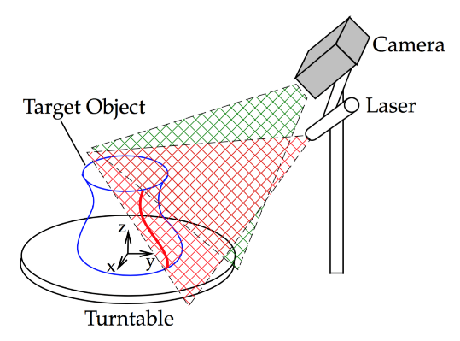
Figure 40: Laser 3D scanning, Image source: http://mesh.brown.edu/desktop3dscan/ch4-slit.html
Additionally, Laser 3D scanning is a type of digital modeling technology that creates accurate 3D models using laser light. Depending on the 3D laser scanner, either a laser point or laser line is directed at the object that is getting scanned. Thousands or hundreds of thousands of data points are recorded from different angles until a full 360° scan is captured. Upon completion, a cluster of data points is created, called a point cloud, which provides engineers with the information to make a CAD and/or mesh file of the object. A list of advantages and disadvantages of laser 3D scanning are listed below:
- Fast & Thorough
- Accurate
- No need for contact with the object
- Cost-Effective
- Safe
Disadvantages of 3D Laser Scanning
- It is impossible to measure any surface that is out of the scanner’s line of sight - including hidden or internal geometry
- Ambient light may blend with the laser and interfere with the scan’s accuracy
- Initial Cost of laser 3D scanners (Advantages & Disadvantages of 3D Laser Scanning, 2020)

4.1.2 Structured Light Scanning
In the structured Light Scanning method, a projector exists that project different light patterns on the surface of an object. The way the objects distorts these patterns is recorded, allowing to create the 3D scan.

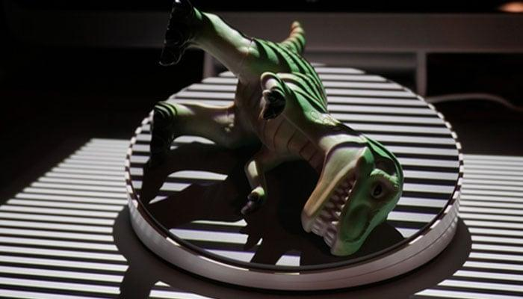

Figure 41: 3D scanning using structured light technology, Image source: https://www.3dnatives.com/en/laser-3d-scanner-vs-structured-light-3d-scanner-080820194/
Structured-light 3D scanners are non-contact 3D scanners, meaning the measurement device does not touch the object in order to get measurement data. This minimizes measurement interference due to physical contact to ensure better accuracy. Structured-light 3D scanners are efficient at capturing measurements (upward of millions of 3D measurement points) with great accuracy (sub-thousands of an inch) in about one second. A structured-light 3D scanner captures a large area of the object at once, which makes the 3D scanning process fast and efficient. Structured-light 3D scanners essentially work like a 3D camera. If the system is pre-calibrated for accuracy during the manufacturing process, minimal setup is required to start the scanning process. The 3D scanning process from data capture to post-processing can be setup to be fully automated.
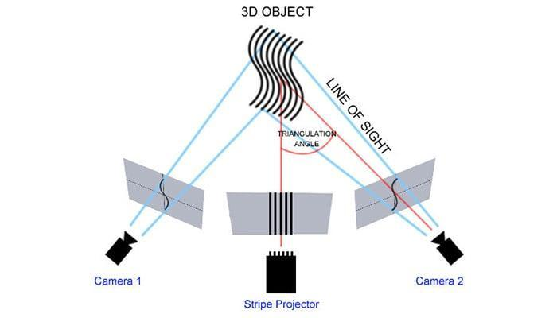

Figure 42: Structured Light Scanner, Image source: https://www.3dnatives.com/en/laser-3d-scanner-vs-structured-light-3d-scanner-080820194/
Among the benefit of structured light technology are:
- Fast scans
- The scanning area is quite large
- Similar to laser scanners, structured light scanners are accurate and offer a high resolution
Some of the downsides of this type of scanner are:
- They are sensitive to the lighting conditions in a given environment
- Working outside would be extremely difficult (V., 2019)

4.2 Photogrammetry
Photogrammetry is a 3D scanning technique for obtaining data from real-world objects by creating 3D models from photographs. Data are extracted from overlapping photos of the object. This makes it possible to capture large objects, even landscapes, that would otherwise be challenging to scan. Photogrammetry is therefore often used by surveyors, architects, and engineers to create topographic maps, networks or point clouds.
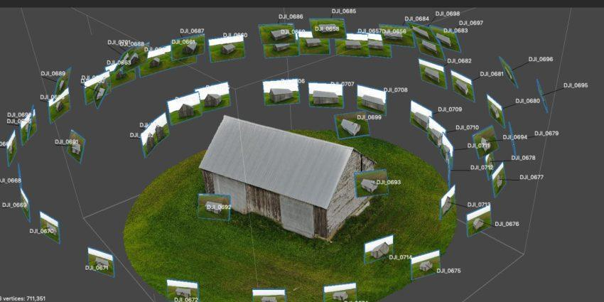
Figure 43: Photogrammetry, Image source: https://bitfab.io/blog/photogrammetry/
In more details, the process is done through the following steps. A series of photographs are taken around the object and by using specific software are converted into a 3D model. By taking photographs (or videos) of the object from different perspectives and with proper lighting, the software is able to find representative or characteristic points of the model that are repeated in all the photos. Further on, with a couple of photographs we can create the so-called stereoscopic effect which is necessary to infer the height of any object on the earth’s surface based on the shadows cast by each object, which allows us to increase the accuracy of the scan.
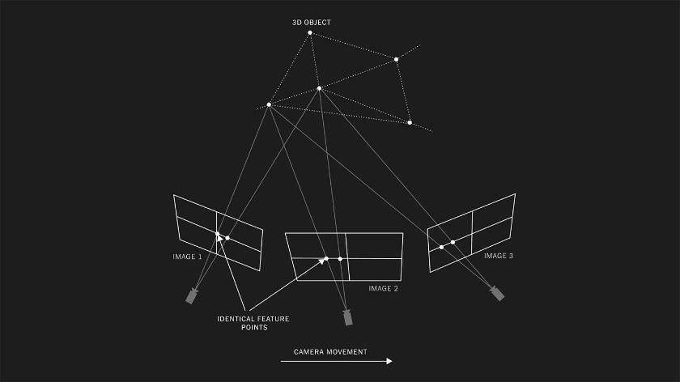
Figure 44: Photogrammetry process, Image source: https://rd.nytimes.com/projects/capturing-images-for-photogrammetry
There are a lot of possible applications for any 3D scanning technique, but photogrammetry is in many cases optimal, since it does not require specialized tools and anyone can do it with just a cell phone or a camera and a computer. However, what is usually required is powerful hardware: most photogrammetry programs require a computer capable to process the images and generate the 3D scanned model. (P., 2022 )
Below is a list of the advantages that Photogrammetry offers:
- Ease and speed at which the data can be collected
- The photogrammetric techniques yield results that are highly accurate making it very reliable to use for mapping or other purposes
- The data that is collected is permanent and accurate and records the condition that existed at the time the photographs were taken in both the pictorial and metric forms
- Due to the fact that the information collected is permanent, it is much easier to re-survey or re-evaluate the site again to get any of the missing information without the loss of any time
- With the use of UAV, UAS, or satellite imagery photogrammetry it is easy to take photos of remote areas and hard to reach locations with accuracy in dimensions
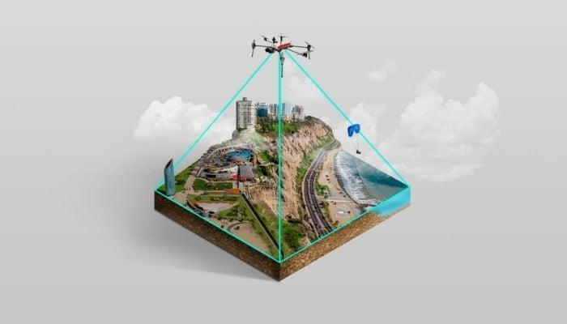
Figure 45: Large scale objects, Image source: https://www.3dnatives.com/en/photogrammetry-what-is-it-and-how-is-it-used-in-3d-printing-300520224/
- A camera and photogrammetry software are usually less expensive, and much easier to transport
- Ability to reproduce an object in full color and texture
- Photogrammetry can work at many scales and sizes while some 3D scanners are limited to a particular sized object
Below is a list of the disadvantages associated with the use of photogrammetry:
- The major disadvantage is that the photogrammetric survey is not possible in the absence of light
- It cannot be used for accurate measurements when there are visibility constraints in the area
- The accuracy of the measurements depends highly on the flight height (Rufai, 2019)
- Textures play an important part in how the reference points are made, and working with smooth, flat, or solid-colored surfaces can be difficult
- Photogrammetry projects can sometimes involve more in-office processing time (Photogrammetry vs 3D Scanning, 2020)

4.3 Applications of 3D Scanning
3D scanning is a technology that is changing manufacturing and engineering processes in several industries. Some common examples are listed below:
- Prototyping & 3D printing
Prototyping and 3D printing is a frequent use case for 3D scanning. 3D scanners enable the capture of a physical product, transform it into a digital format (e.g. STL file format) from which occur prototypes that are then printed by 3D printers. The high level of precision enabled by quality 3D scans significantly streamline this process.
- Reverse engineering & CAD creation
A very common challenge in the world of engineering and product design is creating a CAD replica of a complex object. Using a 3D scanner that will capture the complex geometric characteristics of a given part is a great way to develop a CAD file. Creating high quality CAD files early on in the reverse engineering process can greatly improve the results of the project by minimizing time and effort. (Best Uses of 3D Scanning and Its Applications, n.d.)
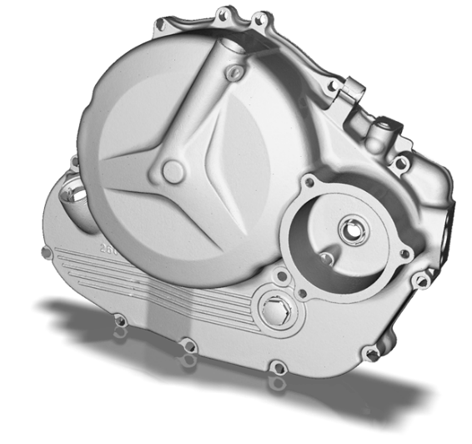
Figure 46: 3D scan of complex objects, Image source: https://www.capture3d.com/knowledge-center/blog/best-uses-of-3d-scanning-software
- Documentation and Archiving
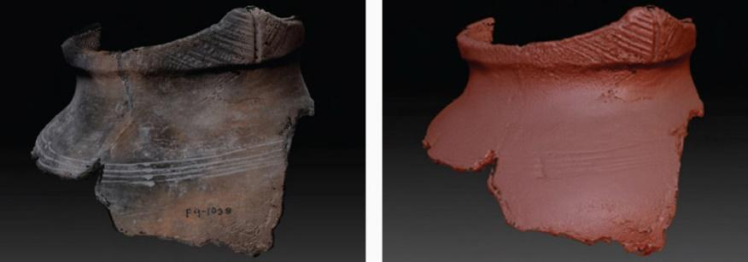
Figure 47: 3D scan of artifacts, , Image source: https://www.capture3d.com/knowledge-center/blog/best-uses-of-3d-scanning-software
Having a digital reproduction of an artifact ensures that if anything happens to the original there is still a digital record of it. 3D scanners help preserve history by capturing delicate artifacts and fossils into 3D digital form. 3D scanners, such as structured-light systems, are ideal for this type of application because they capture the object without causing any disturbance to the original. This technology empowers museums to archive their collections digitally and share them around the world.
- Deviation Analysis
Quickly determine if a manufactured part is within tolerance by comparing the CAD model against the part’s measurements captured with a 3D scanner. 3D scanners’ ability to get 3D measurements of complex and freeform shapes with accuracy and precision make them an ideal solution for quality inspection applications. By comparing CAD model with surface measurements of the manufactured object captured by a 3D scanner, companies can determine if the product is within manufacturing tolerance to reduce product defects.

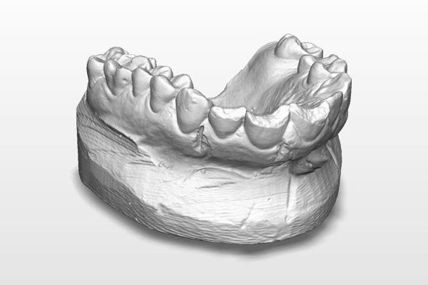
Figure 48: 3D scan of dental products, Image source: https://www.capture3d.com/knowledge-center/blog/best-uses-of-3d-scanning-software
- Create Dental Products Such as Crowns
By 3D scanning dental impressions or tooth, precise and accurate measurements of the patient’s mouth are given to create dental products that provides custom fit for comfort. A 3D scanner can acquire patient’s body measurements quickly in order customized medical products to be created. When it comes to creating one-off customized products for patients, manufacturing products using 3D scanning and 3D printing technologies reduce manufacturing costs compared to traditional methods of manufacturing.
Custom products include:
- Dental: Braces, retainers, and mouth guards
- Face: Form-fitted face mask for treating burn victims
- Body Parts: Making prosthetics (i.e. arm, leg, back)
- Research
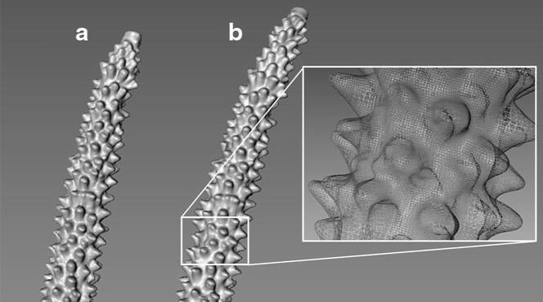
Figure 49: 3D scans for research, Image source: https://www.capture3d.com/knowledge-center/blog/best-uses-of-3d-scanning-software
A digital 3D model contains dense and accurate surface measurements of an object and therefore is useful for research when comparing specimens to see how they are different from one another or how a specimen changes over time. (What is a 3D scanner used for?, n.d.)
- Education
3D scanning is becoming prevalent in classrooms all around the world. By using sculpting clay or a similar medium, students with limited 3D modelling skills are able to create and 3D print unique models that would be very difficult to produce using only a software.
- Architecture
The ability to scan and analyze buildings in high detail makes 3D scanning a hugely attractive proposition in architectural surveys. 3D scanning provides the user with accurate measurements and the ability to fully utilize, visualize and modify data. The ability to rapidly capture high accuracy information means vast savings in productivity and time.
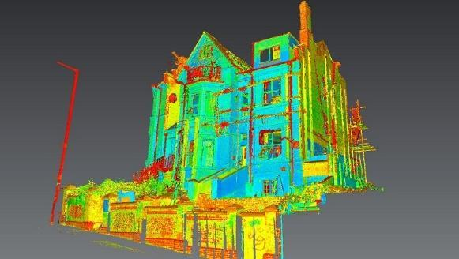
Figure 50: 3D scaning in architecture, Image source: https://www.africasurveyorsonline.com/2019/11/04/3d-building-scanner-how-to-3d-scan-a-building/
- Virtual Reality/Animation
The gaming industry is currently experiencing rapid advancement and 3D scanning appears to play a key role in this growth. Scanning both people and environments provides realistic simulations. (The Real Value of 3D Scanning and its Applications, n.d.)

4.4 Advantages and Challenges of 3D scanning
Traditional scanning is the process of a paper being placed under a flatbed scanner and within a few seconds a softcopy document with the same text, being output on a computer screen. Similarly, 3D scanning stands for “three dimensional” scanning. Just like its ancestor, paper scanning, 3D scanning is a process that analyses an object by capturing its properties like texture, size, color and environment. 3D scanning, therefore, enables the collection of data about physical attributes of objects. This technology brings big advantages but also disadvantages as listed below:
Advantages:
1. Very accurate: Precise trigonometric measurements can be recorded at ease with minimal errors
2. Cost effective: Costs can be reduced by half or even more if proper methods of 3D scanning are adopted. Older data from a 3D scanner can be used to create varying models in the respective field over a long period of time
3. Less manpower involved: Due to the fact that scanning is usually a computer automated process, a corporation may reduce the cost
4. Saves time: Creating a blueprint from scratch requires a long process while with 3d scanning, such procedures are usually automated
5. Easier error correction and detection: Software frequently identifies errors
Disadvantages:
1. Expensive machinery: Equipment may be expensive
2. May require specialists to operate: The involved staff need to have special knowledge
3. Clarity of the scanned template depends on the kind of scanner: For a better quality of scans more expensive scanners may be required
4. Reflections may hider scanning by laser scanners: Material limitations might occur depending on the equipment used (Pros and cons of 3d scanning, 2019)

4.5 3D Scanning in Education
Cut-edge technologies are changing the way people learn. Teachers have the opportunity to take advantage of computers, software and equipment to create interactive spaces for students. A 3D scanner is an important asset within a STEAM Lab since can directly link the sciences, arts and technology sectors. Affordable 3D scanners and software are changing education in several ways such as:
- Accelerating learning
- Create engagement with core topics by transforming learning from abstract to interactive
- Bridging the sense of physical and digital within classroom
- Integrating hands-on learning that can be applied in several learning subjects
3D scanning encourages interaction. When students use 3D scanners, they approach abstract concepts with energy. Students can experiment with modeling core disciplinary topics from the life and sciences, such as math, art, cultural heritage.
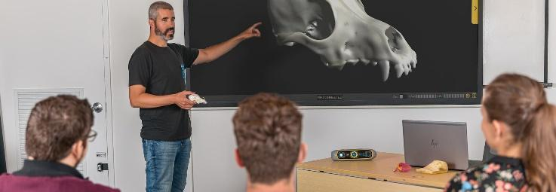
Figure 51: Learning through 3D scanning, Image source: https://peel-3d.com/application/education

Educational environment can be geared toward teaching pupils about engineering and science concepts in a collaborative way. The use of a 3D scanner in a classroom enhances teamwork, and involvement providing an opportunity for planning and carrying out, analyzing, and interpreting data, designing solutions, testing theories by generating evidence, and communicating.
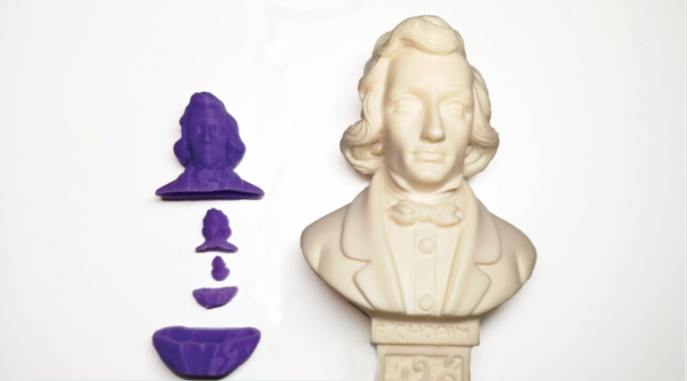
Figure 52: 3D scanning in education, Image source: https://matterandformedu.net/2020/01/23/two-classroom-steam-projects-that-use-3d-scanning/
3D scanning allows students to physically and then digitally model abstract concepts. It also allows reverse engineering where objects lacking technical drawings get deconstructed and understood. Students can create, scan, and study the nature of an object or part. After being studied, the model can be resized or reshaped to fit a new purpose. (Shark, 2018) 3D scanning helps the teachers to teach the pupils how to convert their creative physical ideas into digital 3D models and show them what they can do with their scans afterwards. Primary schools, high schools and art schools can benefit from a 3D scanner. (Education, n.d.)
3D scanning is a useful, versatile educational tool, with the potential to completely transform the classroom environment. 3D scanning in education adds a new dimension to learning. They immerse students of all ages more deeply in the topics they are taught. The potential for 3D scanning to be a transformative educational device encompasses a variety of subjects from science and mathematics to art. As this technology is becoming increasingly affordable it is now becoming a realistic benefit to the modern classroom.
In a three-dimensional learning process students can find, research, or make their own three-dimensional objects. Scanning these objects itself is an iterative learning process. Iterative learning involves repetition and cycles of activity. 3D scanning allows students to experiment as well as to look at and analyze what they are doing as they are doing it. 3D scanning enables students to learn about and investigate scale, quantity and proportion. While scanning real-life objects, students can alter the measurements digitally and see the effects of it.
3D scanning can also encourage students to collaborate more enthusiastically motivating them to work together on investigations, understanding data, creating solutions and communicating their findings. During this process they are provided with a valuable sense of accomplishment.
Another key benefit of 3D scanning in education is that it allows students to deconstruct and understand how items are made even in cases that technical drawings are unavailable. Models can be resized, reshaped and given a new purpose to meet a different need, empowering students and helping them get along with various complex but important concepts, including topics related to science, medicine, engineering, art and many more.
3D scanning technology is the perfect bridge between physical and digital. It uses digital platforms, which many students will already be familiar with the idea of online learning while it demonstrates how digital activity works with actual, physical objects. This is especially useful in demonstrating scientific concepts, by recreating three-dimensional objects in the classroom and analyzing the process. 3D scanners make it easier for students to interact with core topics, bridging the gap between the physical and digital and enhancing the quality of 3D learning. 3D scanning has become a key part of the Next Generation Science Standards learning strategy, promoting experimentation, analysis, and computational thinking.
In addition, using 3D scanners pupils can learn about rapid product development (RPD) and how it shortens the design and development cycle. By speeding up the design process, students have more time to experiment and explore different avenues, without losing valuable classroom time. The range of 3D scanning devices and techniques available means that there are plenty of choices when it comes to educational applications. These devices include high precision scanners and handheld scanners for engineering purposes, visualization and 3D printing. (USES OF 3D SCANNING IN THE EDUCATIONAL SECTOR, 2020)

4.6 3D Scanning in Cultural Heritage
Cultural heritage is human beings’ crystallization of past. Culture relics, however, as time passes by, suffer different degrees of erosion. As a result, heritage conservation and preservation has become an extremely urgent task. People used to manually protect cultural relics by combing photography and rubbing techniques. Although this method can keep the basic information, many vital details would be lost. Nowadays 3D digitalization has been proved to be the most efficient technology and attracted worldwide attention in the field of cultural inheritance. 3D scanning can be used for data archiving, displaying as well as restoration, featuring measurement speed and accurate capturing capacity. Collecting enough and accurate 3D data from different perspectives is beneficial to the restoration of culture relics in cases of accidental damage. (Cultural Heritage Protection by 3D Technologies, 2019)
3D scanning over the recent years has become part of a non-contact and coherent approach to the documentation of cultural heritage and its preservation. High-resolution 3D scans of sites, monuments and artifacts allow the monitoring, study, dissemination and understanding of the shared cultural history. (3D SCANNING FOR CULTURAL HERITAGE CONSERVATION, n.d.) The existence of variety of 3D scanning technologies and 3D scanners considering capabilities and budget has made 3D scanning, virtual and physical replication a reality in the field of cultural heritage preservation. 3D scanning can produce high-precision digital replicas that records the condition, provides a 3D model and makes possible easy mass distribution of digital copies of an artifact. In addition to research, documentation, and replication, a 3D model identical to an artifact can be used for museum collections storage and packing designs. The cost and complexity of 3D scanning technologies in the past have made it impractical for many heritage institutions, but this is changing, as an increasing number of more affordable and suitable for heritage applications. (WACHOWIAK & KARAS, 2009)
Technologies that enable the capture of the cultural heritage such as photography provide a simple but important way to record and document the cultural heritage and therefore make possible its conservation or reconstruction. Similarly, photogrammetry takes a step further in extracting data from a set of photographs. Photogrammetry can translate historical or modern 2D photographs in three dimensional clouds and consequently digitally recreate cultural landscape and archaeological artefacts. The extracted 3D information can be further processed.
3D scanning can contribute in Cultural heritage preservation in the following ways:
- Recording of historic buildings, artefacts, and monuments
- Monitoring of historic buildings, archaeological sites, or geological aspects
- Preservation of architectural drawings of artefacts, monuments in a digital form (Photogrammetry and 3D Laser Scanner in cultural heritage, n.d.)
Handheld scanners combine a relatively low-cost price with the advantage of the portability. 3D scanning has gone a long way since its first appearance in cultural heritage digitization and modeling. The costly and bulky scanners of few years ago are lagging some new emerging technologies that are delivering a long-term dream of the practitioner of cultural heritage: fast, accurate, low cost, “personal” scanning with a handheld device. Using a 3D scanner, it's possible to document an artifact to diagnose problems in its preservation and plan restoration or protection actions, to create a digital representation of an artifact for pure archival reasons, to build a photo realistic representation for use in a virtual tour or to make a simplified representation in order to produce, through 3d printing techniques, a copy (maquette) of the original. (Ippolito, 2017)

4.7 Curricula
For the better understanding of the pupils and the teachers detail learning material was created including theory and practice of 3D scanning. The two main techniques which are photogrammetry and 3D scanning were analyzed in depth. In more details, the learning Objectives were set, and the theory of 3D scanning, photogrammetry and best practices were discussed. Additionally, the partners of the project discussed about the different 3d scanner types (stationary and handled) and 3D scanning techniques such as structured light and laser scanning.
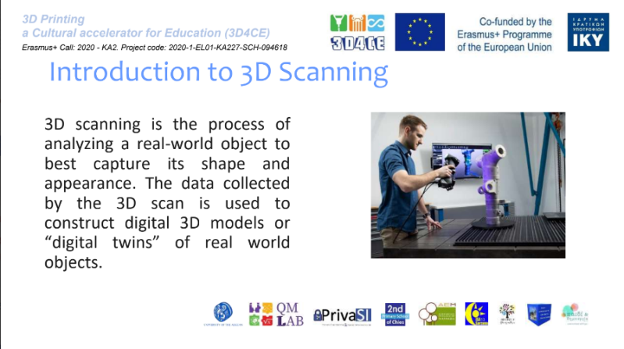 | 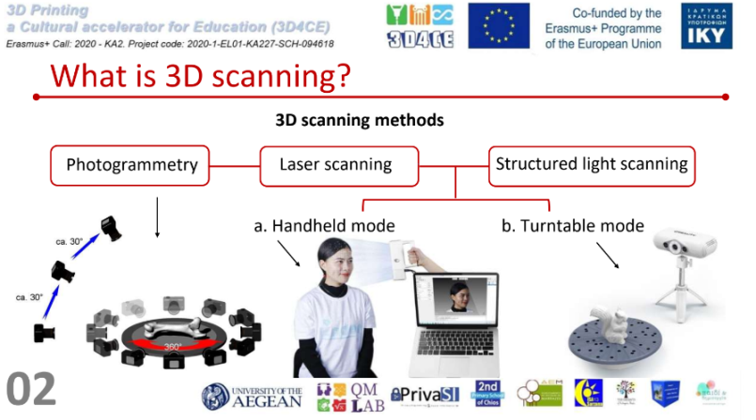
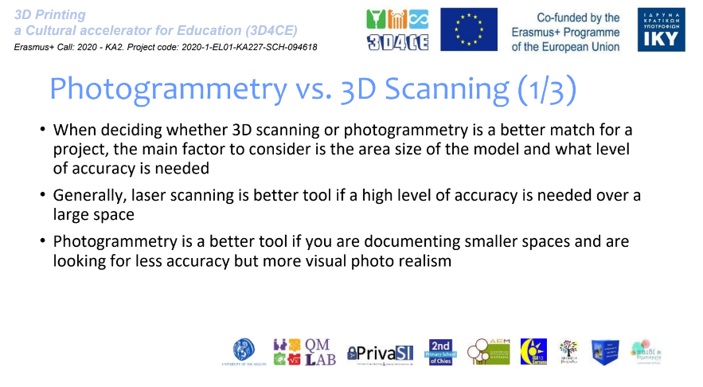 | 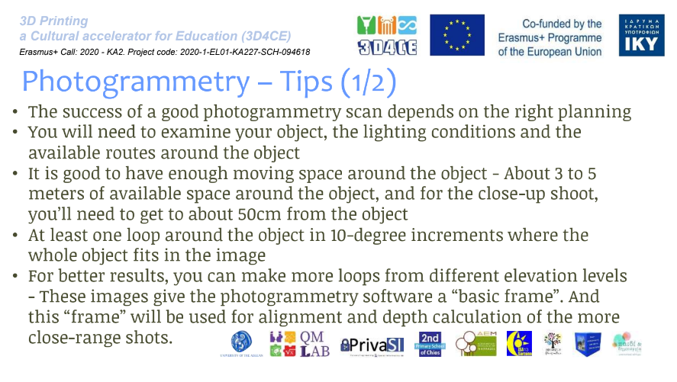
Figure 53: Parts of project’s presentations about 3D Scanning
The hardware was presented, and all the important details were explained. Training combined with 3D scanning labs were conducted. The material created included several types and examples of 3D scanning equipment but was focused on the equipment and software that was used throughout the project, and more specifically the Creality CR-Scan 01 and photogrammetry software such as qlone, trnio, kiri and 3Dscann.
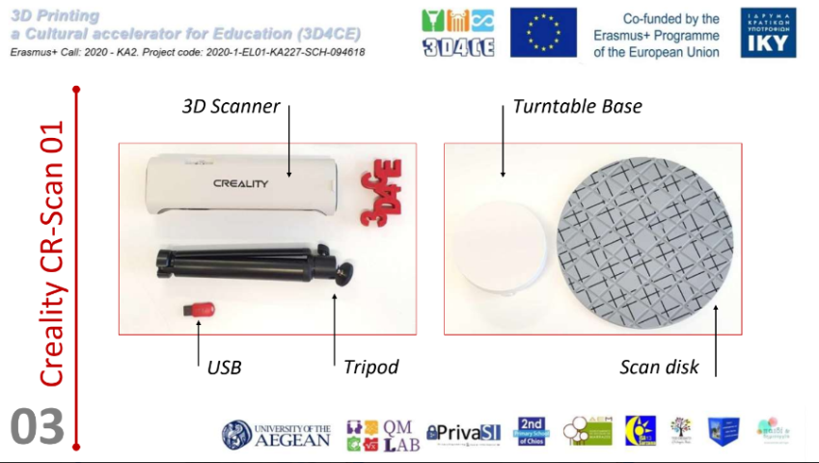 | 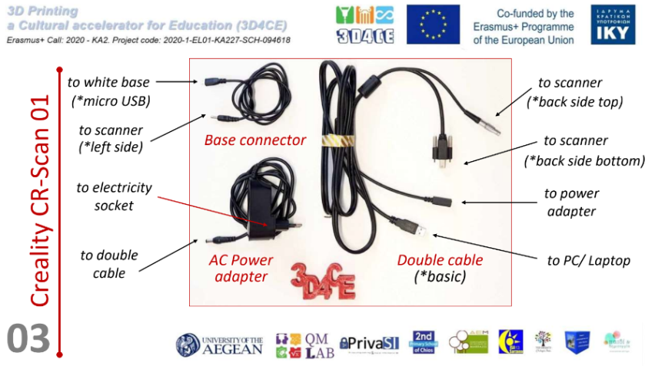
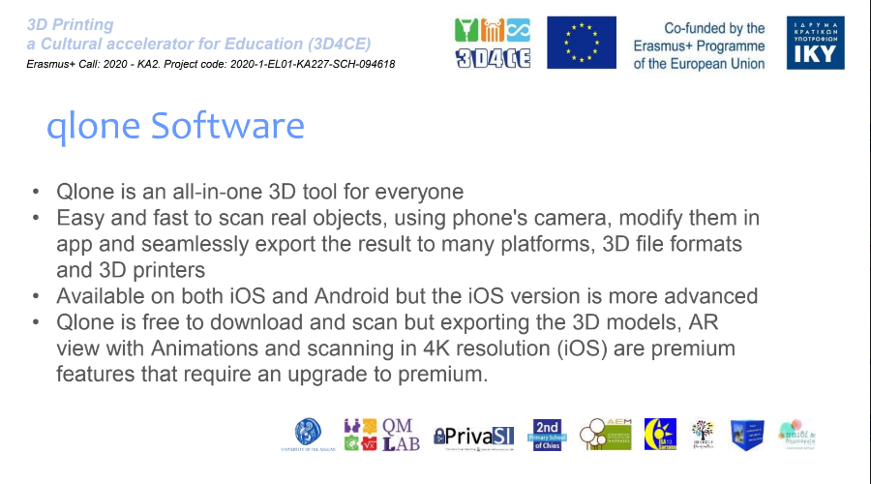 | 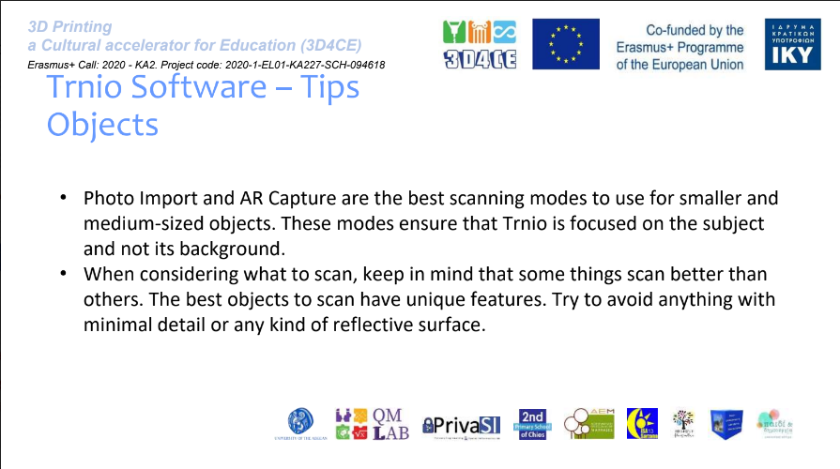
Figure 54: Parts of project’s presentations about 3D Scanning (software and tips)

The 3D scanning process was explained including preparation of the scanner and the objects to be scanned, post-Scanning Process if required and troubleshooting.

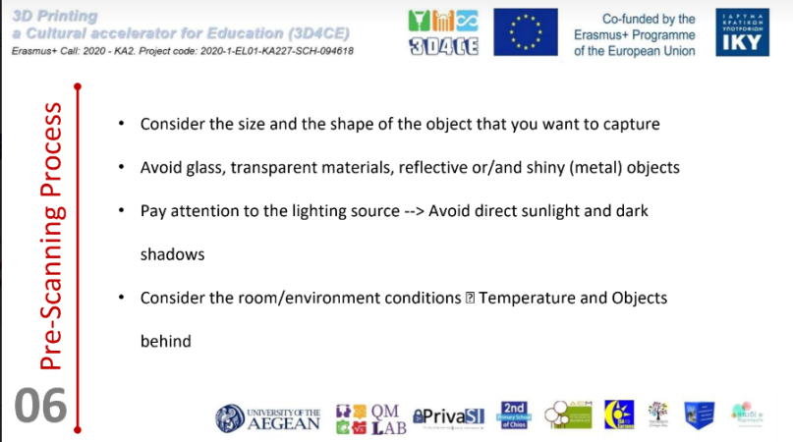 | 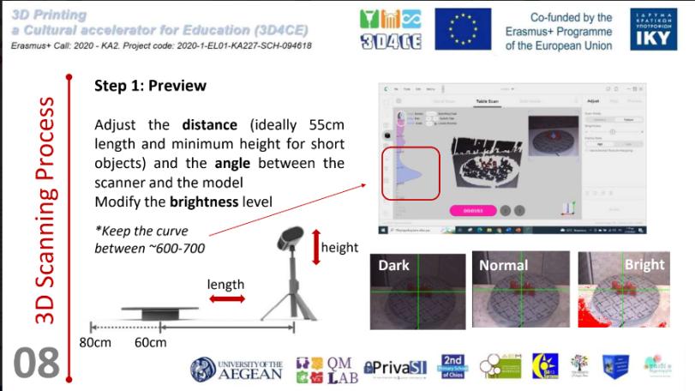
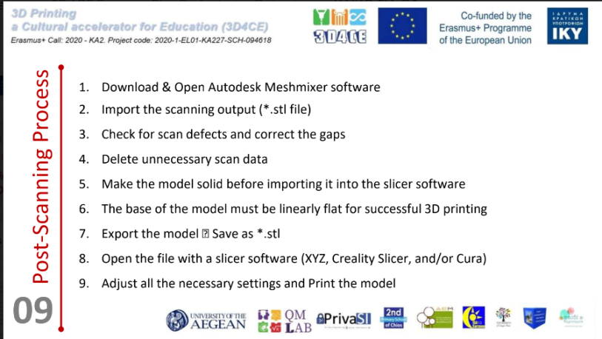 | 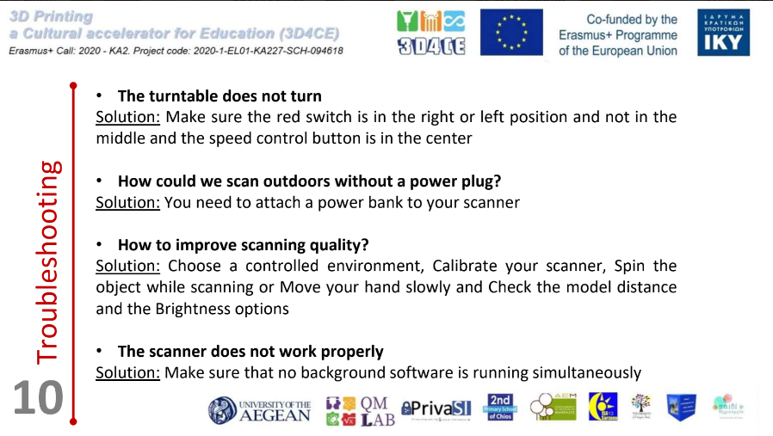
Figure 55: Parts of project’s presentations about 3D Scanning (software and tips)

4.8 Equipment
The equipment used throughout the 3D4CE project for the 3D scanning needs was the 3D scanner Creality CR Scan 01 and android and iOS phones for the photogrammetry projects. There are a few different 3D scanning technologies, including lidar, laser triangulation, SLAM fusion, and structured light, and they all use different techniques. With those come variations in scanners’ accuracy, range, usability and other technical characteristics. Traditionally, 3D scanners have been used for business due to their high price, often ranging from $5,000 to $40,000. However, with the rise of consumer 3D printers, less expensive 3D scanners have appeared. The Creality CR-Scan 01 is an affordable option. Creality is a manufacturer of a wide portfolio of budget 3D printers, including popular options like the Ender 3 V2. Creality CR-Scan 01 has a price just below $650. The CR-Scan 01 uses structured light scanning technology, meaning that it projects light onto a 3D object from different angles. This light is deformed by the present 3D object, and a camera on the scanner views the remaining light beams to create a digital replica of the object. With any 3D scanner, accuracy is an important element. According to Creality, the CR-Scan 01 maintains an accuracy of just 0.1 mm. This accuracy is great given the price, especially considering that other devices cost thousands of dollars more and have the same accuracy.
The resolution is a characteristic similar to accuracy and defines the minimum distance between two points on a scanned object (there are thousands, maybe millions of points in any scan). The CR-Scan has a scan resolution of 0.5 mm, which may not be high enough for very detailed work, but is more than sufficient for simple captures.
The higher the operating distance value, the easier it is to scan larger objects because they can be scanned from further away. On the other hand, the single-frame coverage defines the size of each individual frame that make up the final scan, usually measured in millimeters. It takes an enormous number of frames to scan a large object, so a larger frame size can be easier to work with. This scanner is both handheld and stationary.
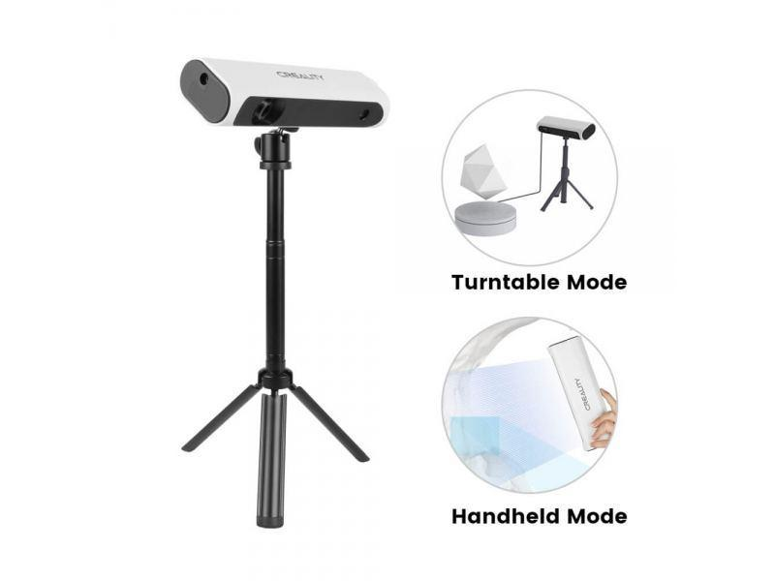
Figure 55: Creality CR-Scan 01, Image source: https://www.3dexpert.gr/eshop/el/creality-cr-scan-01
3D scanners can be handheld, stationary, or a combination of both, with each usage method offering different benefits. Handheld scanners make it easier to scan large models or parts that can’t be placed onto a scanning platform for stationary scanners. Stationary scanners usually offer better accuracy and resolution, and you don’t have to worry about keeping a steady hand. The CR-Scan device, in stock form, is a handheld device, but there’s also an optional tripod and motor-controlled turntable. These accessories allow to convert the CR-Scan 01 into a stationary scanner. For optimal results, objects can be placed on the turntable, which will rotate them so that the scanner (on the tripod) can capture the object’s full design.
CR Studio can be used to process scans which is free to download. While in use, the scanner needs to be tethered to a computer with CR Studio downloaded and opened, via the included USB 3.0 cable.
After finishing scanning, the design can be processed in CR Studio, which will eliminate noise in the scan images, improving the captures. Once this is complete, the scan can be downloaded as either an STL and OBJ 3D model. (O'Connell, 2021)
Scanning with a mobile phone used to require additional hardware such as a depth sensor, but these days, it is possible to scan directly using an app with just a device, thanks to some modern phones being equipped with lidar (light detection and ranging). Both free and for sale options exist but free options were used for the needs of 3D4CE. For Android users the good 3D scanner apps are limited compared to Apple due to the fact the iPhone has integrated technologies into its devices that are dedicated to 3D mapping and scanning, namely the TrueDepth camera system, which launched with the iPhone X in 2017, and lidar technology, which has been available in certain models since 2020. Developers can take advantage of these features for 3D scanning apps. More scanner apps exist for Apple devices but there are quality apps that are compatible with Android devices. Photogrammetry uses photos from different angles to create a 3D digital image. For the needs of the project, photos were taken around larger and smaller objects.
The software stitches the photos together to create a 3D point cloud. Photogrammetry requires 50 to 1,000 images, so this process requires patience. For better results, each picture should be of the best possible quality. Best lighting possible is also important, preferably bright and evenly diffused. The results depend on the camera’s capability.

3D Design

5.1 3D Design and applications
3D design is the process of using a computer-modeling software to create an object with three-dimensional attributes within a 3D space. This means that the object itself has three key values assigned to it in order to understand where it exists within the space. Three-dimensional (3D) design continues to evolve since its earliest inception in the 1960s, which was led by Ivan Sutherland, creator of the world’s first 3D software called Sketchpad. With the evolution of 3D design, designers now have the ability to create CGI (Computer-generated imagery) objects or worlds and make them as realistic as they desire. In addition to improvements made to 3D graphics, computer software used to create these elements has become more efficient and easier to use. (Silveira, 2021)

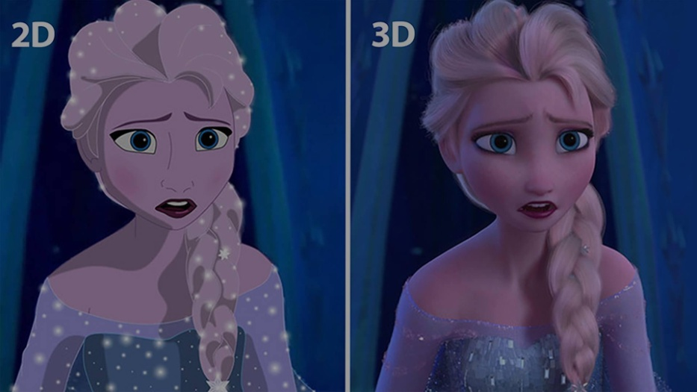
Figure 56: 2D vs 3D, Image source: https://3d-ace.com/blog/2d-vs-3d-animation-which-style-is-winning/
Organizations and professionals across industries use 3D design to communicate ideas, create products and customer experiences, teach concepts, improve lives and more. For example, dentists can X-ray a damaged tooth and produce a 3D model of a crown to repair it, while the film industry uses 3D design to envision scenes and execute special effects. 3D modeling is a concept similar to 3D design since they both involve a software to envision three-dimensional objects. Definitions of these concepts may vary, depending on the brand, software, or company using 3D design or 3D modeling. Briefly, 3D design involves the creation of a 3D object from scratch, starting with a sketch or concept, all the way to completion while 3D modeling is focused on building and fine-tuning the actual visual model of an object and may draw from a 3D designer’s initial sketches.

Several types of 3D design exist. For example, building Information Modeling (BIM) is the design of 3D objects that enables architects, real estate developers, engineers, contractors, and other professionals to create buildings in 3D. BIM designs can include information about parts, materials and actionable steps. Product design is another 3D design type that refers to creating new products or enhancing existing ones through 3D conceptualization, simulation, and design finalization before they are manufactured. Visual effects (VFX) refer to altering, creating or enhancing media for live-action imagery. VFX can be greatly beneficial in cases that capturing live footages would be dangerous, costly or not possible. Virtual reality (VR) refers to the creation of immersive 3D environments and experiences in which individuals, teams, and businesses can visualize concepts, experience simulations, be entertained, collaborate and more. Generative design refers to the process of finding multiple design options based on a concept. Designers or engineers set as input their design goals, requirements, parameters and constraints into a generative design software. The software produces representations of different design outcomes for them to explore. CAD/CAM 3D design refers to computer-aided manufacturing. Innovators, inventors, and machinists use CAD/CAM software to design and manufacture prototypes while expediting the process using automation. (What Is 3D Design? And How to Get Started, 2022)

There is a large amount of 3D modeling software options available and each one has different capabilities. Some examples are given below:
- 3D Transform: A feature available through Adobe XD as a way to turn flat icons and elements into 3D looking objects
- Blender: An open-source tool that is free to use with a lot of capabilities for any designer who is looking to get started in 3D design without committing to a subscription fee
- AutoCAD: A computer-aided design software that can be used both for 2D and 3D projects. It is popular amongst engineers and architects. It is very handy for product design and helps prevent product failures before production
- Autodesk Maya: Maya is a powerful tool and is used by several notable animation studios such as Pixar Animation
- ZBrush: This 3D software is more reasonably priced than Maya and is a great option for beginners and intermediate designers. (Silveira, 2021)

3D modelling is utilized by a large number of industries and for a range of projects. With 3D design, the opportunities are endless. It’s a versatile tool that can be used in many different areas such as game development, 3D printing, architecture, animation and more.
Game development is perhaps the most commonly known use of 3D modelling. 3D models are used for the creation of characters, settings, props and the entire worlds of video games. The key to any good game is immersion, and 3D modelling is a great way to build immersive experiences. Additionally, 3D modelling is essential for virtual reality games. Virtual reality games fully immerse the player in the game experience, creating entire 3D worlds to dive into.

Figure 57: 3D design in game development, Image source: Table 13D in game development, Image source: https://all3dp.com/1/five-games-that-teach-3d-design/ | 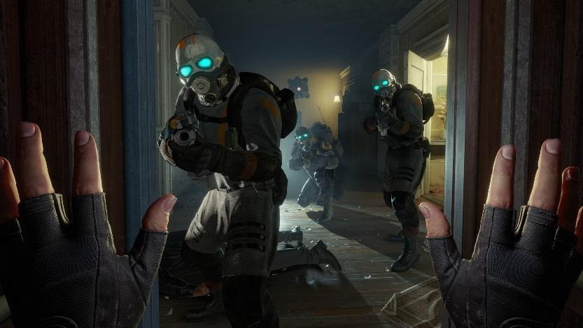  Figure 58: 3D design in VR, Image source: https://mixed-news.com/en/best-vr-games/
Another example is 3D Printing, which would not be possible to exist without 3D modelling. 3D printing is the process that transforms 3D models into physical objects which can be used for the creation of almost anything. Another common use of 3D modelling is architecture, letting architects to design beyond the traditional method of hand-drawn building plans. As technology has evolved, it’s possible to conjure up a three-dimensional visual of a building before it is built. This is useful for envisioning the final product during pitches or to other stakeholders. 3D modelling can reveal potential issues with building structures that 2D plans could not show and is key to modern building design.

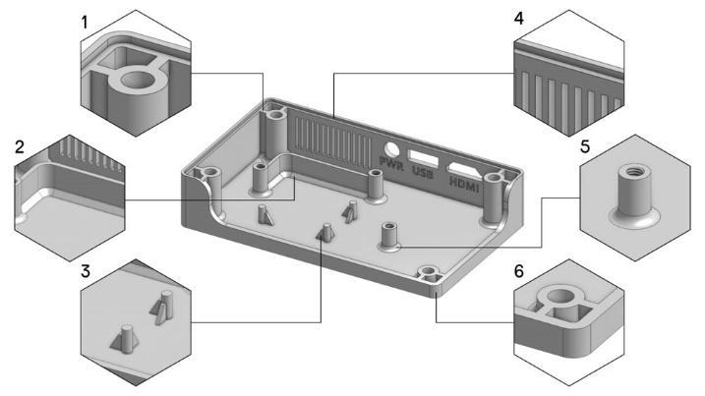  Figure 59: 3D design for 3D Printing, Image source: https://support.makerbot.com/s/article/1667337954399 | 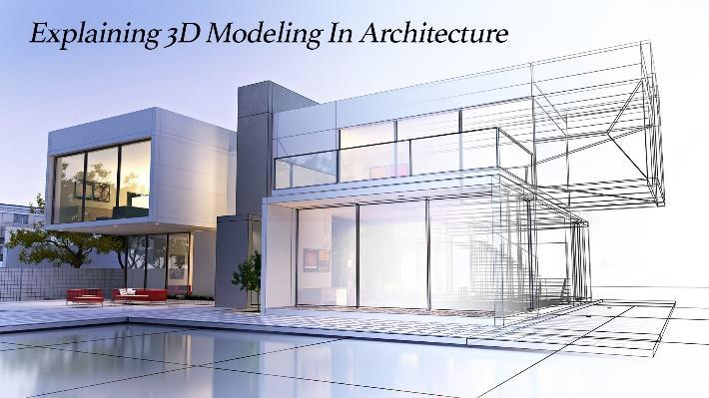  Figure 60: 3D design for 3D Printing, Image source: https://www.thepinnaclelist.com/articles/explaining-3d-modeling-architecture/
Additionally, once a 3D model exists, it can be completely rigged and animated. Animators use 3D models for a clean, seamless effect when creating movies and TV shows. Throughout the process, 3D modelling is used to create scenery, characters, props and much more. Most animated movies will utilize some kind of 3D programming software.

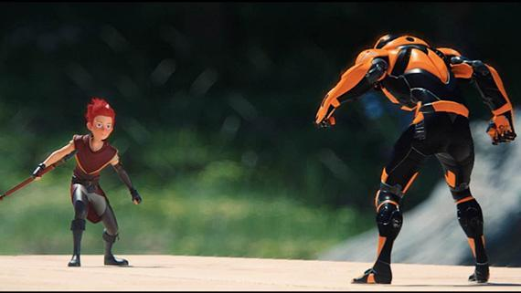
Figure 61: 3D design in animation, Image source: https://www.artemisiacollege.com/3d-animation-2/
Further on, many of the products that exist in day-to-day lives had some 3D modelling involvement. By creating a virtual 3D model of a product before it is physically created, any errors can be avoided, and adjustments can be made to the product whenever necessary. Even the ability to see the object’s size relative to other products can make a difference in the production process. It is also useful for pitching product ideas to investors, as products can be showcased at a 360-degree angle, allowing stakeholders to fully envision the final result. It’s also less wasteful than creating samples and repeatedly making mock-products, and sustainable product design is an important step in the right direction.
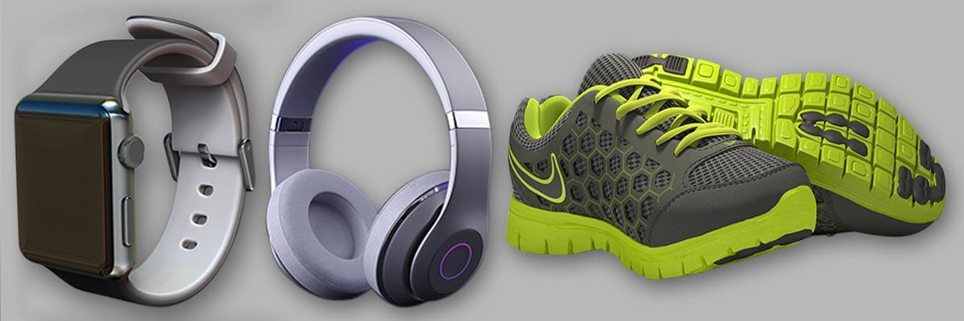
Figure 62: 3D product design, Image source: https://www.nbyit.com/3d-product-design/

5.2 Advantages and limitations of 3D Design in education and cultural heritage
Using 3D models in the education proses offers a lot of advantages. The process is highly interactive and therefore very effective. Students frequently have a short attention span, kids are likely visual learners, and it’s more convenient for them not only to listen to the teacher or look at the sketches but also discover by using a visual 3D representation. The retention of information obtained by a pupils during a session including 3D technologies increases significantly. Additionally, it is essential in cases that the objects the teachers talk about does not exist in real life, or when people are unable to see them without using special equipment, such as cells, planets, or bacteria. An example is an electrical scheme that would usually be demonstrated as a sketch, something that would be dull for young minds. Models can be created that help not only to see the real system but also triggers active interest to learn more about electricity and physics.
Seeing an object in “real life” is more interesting, detailed and effective in education. Teachers also have a lot of advantages since they can explain, demonstrate objects and really motivate students to be interested in science and education. (Why 3D Models Are Great for Education, 2021)

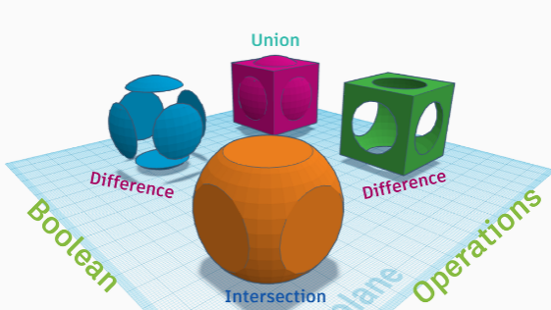  Figure 63: Instructional 3D design, Image source: https://www.instructables.com/How-to-Teach-the-Language-of-3D-Modeling-and-Desig/ | 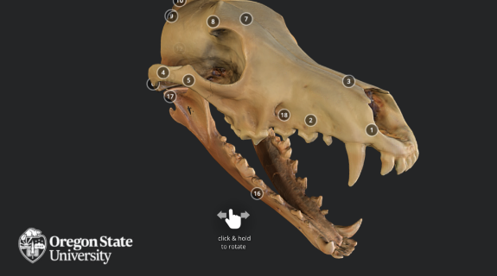  Figure 64: 3D objects in education, Image source: https://blogs.oregonstate.edu/inspire/2018/08/15/5-ways-3d-models-can-help-in-education/
Furthermore, 3D technologies offer access in a realistic way to primary source material — the things themselves — rather than the textual observations or interpretations that come from traditional teaching material, like books and journal articles. To this end any real-world object could be a candidate for digital reproduction and curricular integration.
Academic fields of study that are relevant to artifacts, specimens, and anatomical structures could be greatly benefitted from 3D content. 3D models also offer new ways to engage with materials—using features like cutaway visualization, surface curvature measurement, and multispectral analysis. Some examples are:
- Organic Chemistry students can engage with protein molecules on the web or in virtual reality.
- 3D sculptures could be virtually examined during art history classes, instead of visiting a museum.
- 3D makes it possible to walk through historical architecture at human scale (COOK, n.d.)
- Solve real-world problems and encourage students to find real-world solutions by inventing an item or solving a STEM challenge
Students can prepare custom 3D models or search in the many available resources for finding and using models for instructional purposes. Thingiverse and Sketchfab offer free models and projects that students can download, share, and print on a 3D printer. Yet, working with 3D isn’t just about finding the ultimate item to share and passively view with students, it’s an opportunity to creatively ignite student learning. Students can become designers; students can literally take imagined ideas from conception to fruition. This is a key skill called out in the Designer standard within the ISTE Standards for Students. A variety of beginner friendly software exists such as:
Tinkercad is a simple online 3D design interface that allows users to manipulate, shape and link geometric shapes in a virtual space to create 3D models. Users can immediately create and download their designs in .STL or .OBJ files for 3D printing or sharing. Tinkercad is a great starter tool for anyone interested in working with 3D design and allows teachers to moderate the student accounts.
Mecabricks interface is compelling to any user who is a fan of Lego building blocks. It offers the opportunity to build a 3D virtual surface with Legos. Students can place, build and link virtual Legos and save them as .OBJ or .STL files to print and share.
Doodle 3D is a friendly, almost cartoon-like interface offering the ability to create and use non-linear designs and shapes. It allows the user to create a customized 3D design experience considering that they can draw in addition to placing geometric shapes. Similar to the other tools, users can print, share, or download in. STL or .OBJ format. (Howard, 2018)
Some limitations can also occur by the usage of 3D technologies for educational purposes. In some cases, the teacher’s efforts can be constrained by technical issues caused by the used equipment. Additionally, when the purpose of the design is 3D printing, time and complexity constrains can occur. Internet connectivity and resource issues could also cause limitations in some cases. Furthermore, usability issues may come up for the young learners when using the 3D design software. Some of these issues are related to the execution of app functions, for instance, difficulty creating, resizing, rotating and joining objects, and therefore the teachers would need to provide assistance to the students to interpret and operate the app.
Learning challenges could be faced often related to underlying problem-solving capabilities, including the ability to form and ask questions, knowing how to deconstruct the problem, and having a clear idea about what to design. Further on, children may face difficulties understanding mathematical reasoning associated with rations and dimensions. Teachers’ confidence with the technology can also be a challenge while time might be insufficient for teachers and students in order to optimize and implement their lessons. (Bower, Stevenson, Forbes, Falloon, & Hatzigianni, 2020)
Another sector to which 3D models have an important value is Cultural Heritage. The last decade’s technology has been increasingly involved with cultural heritage. The usage of modern techniques offers the ability to help to record, conserve and recreate cultural heritage. 3D modeling has become a useful tool when it comes to cultural heritage since it allows the possibility to create accurate representations of surfaces, objects, and structures. 3D models can replicate not only an object’s geometry, but also its texture and color.
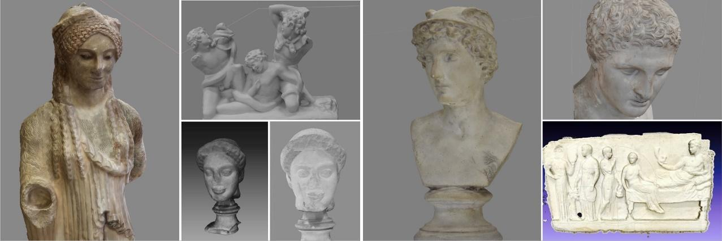
Figure 65: 3D models in Cultural heritage, Image source: https://sketchfab.com/blogs/community/creating-3d-models-for-cultural-heritage-in-the-classroom/
Hence, these representations increase their utility for different disciplines, and are becoming valuable assets when thinking about cultural heritage. Nevertheless, several challenges also exist regarding 3D modeling in cultural heritage, such as the need of detailed documentation of complex 3D geometries, dealing with large-scale data, increased computational requirements, usage of low-cost techniques for 3D data acquisition, and dealing with archaeological uncertainty in virtual 3D reconstructions. 3D models can be used for documentation, restoration, conservation, presentation, and research purposes in cultural heritage, and in more details:
Restoration
The majority of cultural assets are susceptible to deterioration or damage through time, frequently caused by external factors such as environmental conditions, light exposure, material degradation, exposure to rain and/or wind, insects, inadequate storage, human interaction, etc. Therefore, in most of these cases, the object or structure would need to be restored, while having a 3D model created beforehand would be a valuable resource for an accurate and successful restoration. Organizations such as UNESCO have created a list of “World Heritage Sites in Danger” in order to prioritize their conservation. UNESCO has stated that the cultural and artistic value of these sites has been compromised, and they are carrying out a process to create 3D models of all these sites in order to be restored if necessary.
Monitoring
In relation to the damage and deterioration that cultural sites and objects can suffer, it is essential to also take under consideration monitoring. Degradation is a progressive process, meaning that objects and structures get damaged or deteriorated at small stages through time and in most cases, it is imperceptible to common view. 3D models can help to determine changes or alterations in the morphology and disposition of an objects and structures, which provides the possibility of foreseeing and therefore taking the necessary actions on time.
Research
3D models are useful for performing a broad amount of analysis and research. With a 3D model it is possible to make several types of analysis such as comparative analysis of morphology, changes on structure, measuring, distribution, architecture, textured, disposition. For example, photogrammetry has been used as a non-invasive procedure to analyze, measure, archive and recreate artwork, a useful option when working with fragile artwork, since it makes possible to restore an object without being in physical contact with it.
Conservation
3D digitization meets the needs of methodologies and procedures that deal with conservation and archiving of cultural heritage. Creating 3D models of cultural materials and heritage sites is a reliable and accurate mean to conserve these assets for the future.
Documentation
While working with cultural materials either in the field, the lab or the museum, documentation is a very important aspect, since it provides content to objects and places, meaning that it keeps record about the context, origin and background information associated with a specific artifact. 3D models enable the usage of modern and accessible techniques to enhance documentation in the field, as well as creating 3D replicas of the materials and surfaces.
Representation
Having digital models of cultural assets makes them accessible, even when the physical access is restricted or hard to reach. 3D digitization of cultural heritage also provides the option of developing replicas and accurate representations that can be exhibited instead of using the original artifact. This enhances the interaction between people and cultural heritage and safeguards the physical integrity of the original object. (Chacon, 2016)
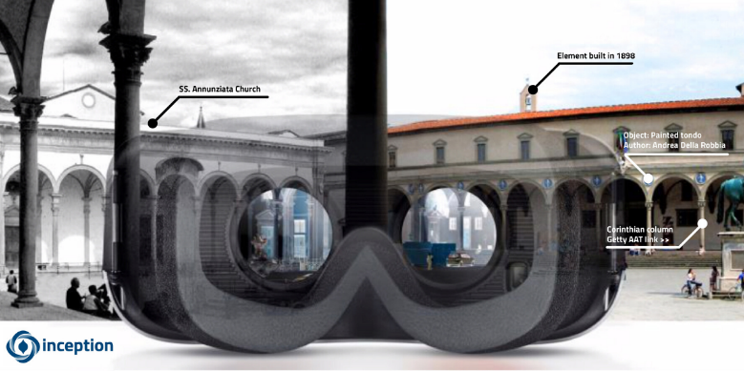
Figure 66: Representantion of Cultural Heritage, Image source: https://pro.europeana.eu/post/3d-models-to-explore-our-built-cultural-heritage-the-inception-technologies

5.3 3D Models libraries
Rather than creating 3D models from scratch, it’s often way easier using an already built 3D model and altering the piece to fit the desired requirements. There are many tools available varying regarding 3D model’s types and price.
Cults 3D provides a wide selection of 3D models for purchasing, selling, and creating free 3D models to use. Available objects can 3D printed such as phone holders, separators, and clips. Custom 3D designs can be requested from a creator by giving enough details, certain budget, and a deadline. The target is designers and hobbyists, and the size of Cults 3D is 5,000+ models. It has a free and a payable model.
Yeggi is a powerful search engine allowing users to find free 3D models to print, without needing to sign up. It has both free models and models available for purchase. With over 2 million different models to choose from, the Target is CAD designers, engineers, and hobbyists
Thingiverse has 9,000+ free models 3D for 3D printing. The target audience is makers, engineers, and designers
Hum3D is compatible with 3DS Max, Maya, Blender 3D, Cinema 4D, SketchUp and more. It is a great outsource for free 3D models and objects archive. The target is design, AR, and visualization and contains 17,000+ models. The price depends on the demand. (The Best 3D Model Databases for Visualizations and 3D Printing, 2020 )

5.4 Tinkercad
Tinkercad was launched as a free web-based 3D modeling tool by Kai Backman and Mikko Mononen in 2011. One year later, Tinkercad had over 100,000 user-created designs and recognizing the opportunity, Autodesk acquired Tinkercad in 2013. In 2017, Autodesk added circuit modeling and, later on a coding tool to create the Tinkercad we know today. Tinkercad being free and available via a web browser (accessible via PC or tablet), is popular with beginners and for classroom use.
Tinkercad is a popular 3D modeling, circuitry-simulating, and block-coding software package that’s accessible for free via a web browser. Its popularity is a result of its user-friendly simplicity. It consists of three sections, each of which can be considered its own endeavor and be used for different purposes. 3D design with Tinkercad is simple. The design concept is based on adding and subtracting simple shapes – for example, creating a pipe by starting with a large solid cylinder and then subtracting a smaller cylinder from it. Towards this end, the main operations are copy, paste, group, ungroup, align, and mirror. But you also have the ability to adjust dimensions, colors (which is great for organization), and the number of facets on round bodies. This simple concept is further simplified by the large library of shapes, which can be easily accessed and manipulated. Nonetheless, complex items can be designed with Tinkercad.
Everything is click, drag, and release, but it doesn’t have to be. If you require exact measurements, you can enter them with your keyboard, as well. As mentioned earlier, a host of keyboard shortcuts allow alternative ways to access the design tools available. (Giencke, 2022)

5.5 Blender
Blender is a free and open-source 3D creation suite. It supports the entirety of the 3D pipeline—modeling, rigging, animation, simulation, rendering, compositing and motion tracking, even video editing and game creation. Advanced users employ Blender’s API for Python scripting to customize the application and write specialized tools; often these are included in Blender’s future releases. Blender is well suited to individuals and small studios who benefit from its unified pipeline and responsive development process. (The Freedom to Create, n.d.)
Blender’s interface is very straightforward, with all the main tools on the left, all the properties and options to the right, and the main controls down at the bottom. You can modify and change your Viewports (the window you’re seeing a model or scene in) in a variety of ways.

The release of Blender 2.8 offers a greatly improved system for quick commands and radial menus that let you get to the tools you need in as few clicks as possible. There’s an active community surrounding Blender, boosted by the fact that it’s open source, meaning there’s a lot of help and advice to be found. From tutorials to threads, you can find answers to all things Blender on their support page, WikiBooks, CG Cookie (paid service with a free trial). There are also communities that are more specific to particular parts of Blender, such as materials. If you aren’t sure what you want to design or are looking for inspiration, there’s a great community at Blendermada with a huge materials database. (Hartmann, 2020)

5.6 Meshmixer
Autodesk meshmixer is a free software for the creation and manipulation of 3D models for 3D printing. Whether clean up a 3D scan, do some 3D printing or design an object is needed, meshmixer can help. Meshmixer is simple and easy to use. A range of 3D file types can be loaded in to Meshmixer including STL, OBJ, PLY and AMF. Importing a model is simple. Simply open the software, click Import and select the file you wish to load. Once the 3D model is loaded, the next step is manipulating the model if needed or simply rotate to optimize for 3D printing and export. 3D printing, ideally needs two things: The object to sit flat on the build plate if possible, and minimum overhangs.
The ability to reduce the file size of a 3D model is useful, particularly if the model is a high quality scan as these can often be over 100MB. A 3D file is generally made up of a series of triangles. The greater this number of triangles the more detailed the model and this means a larger file size. In the case of a high-quality 3D scan, reducing the number of triangles fairly substantially will not have a huge effect on the overall quality of the 3D print.
The ability meshmixer offers to accurately measure every aspect of a 3D model can be very useful. With Meshmixer you are able to split up a 3D model into multiple slices. This can be very useful if you have a large model that requires 3D printing as separate components. Support can also be produced in Meshmixer. Meshmixer is capable of many useful tools, not only for editing but also for sculpting and producing unique 3D designs. (10 steps to getting started with Meshmixer for 3D Printing, n.d.)

Conclusions
The use of technology in education is becoming increasingly important as educational institutions seek to provide the best possible learning experience for the students. To engage students in learning, a teacher would need to be innovative and new ideas should be introduced so that students get excited about the learning material. The vast array of educational technology that is available today offers teachers a wide range of options from which they can choose the best ones for their educational needs. This helps them develop the right kind of skills and knowledge so that they can become good professionals in their chosen field. Learners who are able to communicate better through technological means will also perform better academically as well as in future work settings considering that technological skills are very important. In addition, considering that today's learners are not only required to learn but they also need to have fun while doing so, educational technology offers students the opportunity to have fun while learning, which will also help them stay motivated and excited about their studies. Learning new skills and acquiring knowledge are two very important aspects of life that students should be able to enjoy. The benefits of using educational technology also include the improvement of learners' mental and physical health. Big Data, Machine Learning, and the Internet of Things (IoT) have been some educational technological trends (Alexander, 2021).
Based on the literature, the most effective method of education is experiential, when learning is achieved through personal experience and reflecting on it. Disciplines such as environmental science, electrical engineering, studio art, and others that are inherently hands-on lend themselves to this type of teaching and learning. Considering that some objects of study are inaccessible except by proxies and models (e.g., molecular biology, urban planning, and theoretical physics), 3D technology is that enables experiential teaching and learning in many disciplines where it would otherwise be challenging or impossible. Therefore, 3D technology can make the invisible visible, the inaccessible accessible (Pedagogical Uses of 3D Tech, n.d.).
Technology has made it possible for everyone to stay connected. Students and teachers connect, discuss, share their opinions, and act upon situations collaboratively. For example, eLearning is an educational tool that features collaboration. Furthermore, both learners and educators could be benefitted from AI. For example, students could get help from AI tutors. Also, AI-driven programs can give both learners and educators helpful feedback. Some schools already use AI systems to monitor student progress and to alert teachers when there might be an issue with students’ performances.
The current landscape of learning analytics has expanded, especially for higher education. Learning analytics allows educators to measure and report student learning, allowing them to better understand and optimize learning. For instance, teachers are able to see what type of information (text, images, infographics, or videos) students enjoy most. Also, teachers can notice what pieces of knowledge weren’t effectively delivered and enhance them. Moreover, learning analytics helps educators identify blocks of students who may have academic or behavioral challenges and develop a way to help students reach their full potential.
The initial goals of the present deliverable including the introduction of 3D Printing technology and methods for learning design to the teachers and the students, the learning of open sources software that help pupils make their own designs, the creation of a framework that describes in details how 3D Printing technology helps and support students to understand cultural heritage along with the designing and completing of series of activities for learning cultural heritage and using 3D were achieved. 3D4CE project overall and particularly the O3 is innovative since it successfully applied the theory of 3D technologies both in education and cultural heritage and additionally offered the opportunity of hands-on evaluation of these theories by the teachers and students.

Literature review
- 10 steps to getting started with Meshmixer for 3D Printing. (n.d.). Retrieved from weareprintlab: https://weareprintlab.com/blog/10-steps-to-getting-started-with-meshmixer-for-3d-printing
- 3D Printers for Biology Education. (n.d.). Retrieved from 3d supply guys: https://3dsupplyguys.com/education-center/3d-printers-in-education/3d-printers-for-biology-education/
- 3d Printing Industry. (n.d.). Retrieved from The Free Beginner’s Guide: https://3dprintingindustry.com/3d-printing-basics-free-beginners-guide/#03-technology
- 3D printing.com. (2022, December). Retrieved from https://3dprinting.com/what-is-3d-printing/
- 3D SCANNING FOR CULTURAL HERITAGE CONSERVATION. (n.d.). Retrieved from factum foundation: https://www.factumfoundation.org/pag_fa/701/3d-scanning-for-cultural-heritage-conservation
- Advantages & Disadvantages of 3D Laser Scanning. (2020). Retrieved from 3space: https://3space.com/advantages-disadvantages-of-3d-laser-scanning/
- Advantages of 3D printing. (n.d.). Retrieved from tractus3d: https://tractus3d.com/knowledge/learn-3d-printing/advantages-of-3d-printing/
- Ahmed, S. (2022). 10 Cool Things to Make With a 3D Pen For Beginners. Retrieved from https://3dgearguide.com/cool-things-to-make-with-a-3d-pen-for-beginners/
- Alexander, L. (2021). Educational Technology: How Important Is It In Today's Education Industry? Retrieved from elearning industry: https://elearningindustry.com/how-important-is-technology-in-todays-education-industry
- Alexandrea, P. (2020). 3D Printing Materials Guide: Plastics. Retrieved from 3dnatives: https://www.3dnatives.com/en/plastics-used-3d-printing110420174/
- Alom, Z. (2022). 3D Pen— Make 3D Printings Easier And More Customizable. Retrieved from realtechpoint: https://realtechpoint.com/3d-pen-make-3d-printings-easier-and-more-customizable/
- Best Uses of 3D Scanning and Its Applications. (n.d.). Retrieved from capture3d: https://www.capture3d.com/knowledge-center/blog/best-uses-of-3d-scanning-software
- Bower, M., Stevenson, M., Forbes, A., Falloon, G., & Hatzigianni, M. (2020). Makerspaces pedagogy – supports and constraints during 3D design and 3D printing activities in primary schools. Educational Media International, 1-28.
- Bui, S. (2020). Top Educational Technology Trends In 2020-2021. Retrieved from elearning industry: https://elearningindustry.com/top-educational-technology-trends-2020-2021
- Carolo, L. (2021). 3D Printed Food: All You Need to Know. Retrieved from all3dp: https://all3dp.com/2/3d-printed-food-3d-printing-food/
- Chacon, R. (2016). 3D Modeling and Cultural Heritage. Retrieved from medium: https://medium.com/digital-heritage/3d-modeling-and-cultural-heritage-ef2bffdeec7f
- COOK, M. (n.d.). Teaching and Learning with 3D Content. Retrieved from Harvard Library: https://library.harvard.edu/services-tools/teaching-and-learning-3d-content
- Cultural Heritage Protection by 3D Technologies. (2019). Retrieved from 3d-scantech: https://www.3d-scantech.com/cultural-heritage-protection/?gclid=CjwKCAiAuOieBhAIEiwAgjCvcvCzWul0VZ0fqoGHbwPLeP17obRjETCfXKtPTtsBeuaETJtQS9AbcRoCsGkQAvD_BwE
- da Vinci miniMaker 3D Printer. (n.d.). Retrieved from xyzprinting: https://www.xyzprinting.com/en/product/da-vinci-minimaker
- Education. (n.d.). Retrieved from scan dimension: https://scandimension.com/pages/3d-scanner-for-education-school
- Everything About a 3D Printing Pen. (2018). Retrieved from manufactur 3d: https://manufactur3dmag.com/everything-about-a-3d-printing-pen/
- Ford, S., & Minshall, T. (2018). Invited Review Article:. Additive Manufacturing.
- Giencke, A. (2022). What Is Tinkercad? – Simply Explained. Retrieved from all3dp: https://all3dp.com/2/what-is-tinkercad-simply-explained/
- Guide to 3D Printing In Education. (n.d.). Retrieved from formlabs: https://formlabs.com/eu/blog/guide-3d-printing-education/
- Hartmann, T. (2020). What Is Blender (Software)? – Simply Explained. Retrieved from all3dp: https://all3dp.com/2/blender-simply-explained/
- Heiss, E. (2020). TEACHERS, 3D PRINTING AND STEAM: MATHEMATICS. Retrieved from https://www.ysoft.com/en/blog/2020/teachers-3d-printing-and-steam-mathematics
- HOW ARTIFICIAL INTELLIGENCE CAN HELP THE CULTURAL HERITAGE SECTOR: SAINT GEORGE ON A BIKE. (2022). Retrieved from Time machine: https://www.timemachine.eu/how-artificial-intelligence-can-help-the-cultural-heritage-sector-saint-george-on-a-bike/
- How does 3D scanning work? (n.d.). Retrieved from sculpteo: https://www.sculpteo.com/en/3d-learning-hub/basics-of-3d-printing/what-is-3d-scanning/
- Howard, M. (2018). Harness the power of 3D models in the classroom. Retrieved from iste: https://www.iste.org/explore/Computer-Science/Harness-the-power-of-3D-models-in-the-classroom
- Industrial Applications of 3D Printing:. (2021). Retrieved from amfg20: https://amfg.ai/industrial-applications-of-3d-printing-the-ultimate-guide/
- Ippolito, A. (2017). Handbook of Research on Emerging Technologies for Architectural and Archaeological Heritage.
- J., M. (2020 ). The Top Eight Alternative 3D Printer Filaments. Retrieved from 3dnatives: https://www.3dnatives.com/en/alternative-3d-printing-filament230820184/#!
- Kivolya, N. (2019). How to 3D scan an object with a portable structured light scanner. Retrieved from artec3d.
- Kivolya, N. (2019). What are 3D scanners used for? Retrieved from artec3d: https://www.artec3d.com/learning-center/what-are-3d-scanners-used-for
- Koslow, T. (2017). XYZprinting da Vinci miniMaker Review: Just A Toy. Retrieved from all3dp: https://all3dp.com/1/xyzprinting-minimaker-review-an-underwhelming-printer-for-beginners/
- Listek, V. (2019). A New Ally for Preserving Cultural Heritage: Realistic 3D Printed Models. Retrieved from 3dprint: https://3dprint.com/238467/a-new-ally-for-preserving-cultural-heritage-realistic-3d-printed-models/
- Locker, A. (2020). Creality Ender 3 Pro Review: Great 3D Printer Under $300. Retrieved from all3dp: https://all3dp.com/1/creality-ender-3-pro-3d-printer-review/
- Mashambanhaka, F. (2019). Is a 3D Printing Pen a Toy or a Serious Tool? Retrieved from all3dp: https://all3dp.com/2/is-a-3d-printing-pen-a-toy-or-a-serious-tool/
- MCDONALD, L. (2019). 3D-printed glass: Where are we now? Retrieved from The American Ceramic Society: https://ceramics.org/ceramic-tech-today/glass-1/3d-printed-glass-where-are-we-now
- Motley, D. (2017). CHOOSING BETWEEN A STATIONARY OR HANDHELD 3D SCANNER. Retrieved from gomeasure3d: https://gomeasure3d.com/blog/stationary-or-handheld-3d-scanner/
- Neumüller, M., Reichinger, A., & Rist, F. (2014). 3D Printing for Cultural Heritage: Preservation, Accessibility, Research and Education. In 3D Research Challenges in Cultural Heritage (pp.119-134).
- O'Connell, J. (2021). Creality CR-Scan 01: Review the Specs. Retrieved from all3dp: https://all3dp.com/2/creality-cr-scan-01-review-specs-3d-scanner/
- Ofek, A. (n.d.). Should I Buy a 3D Pen? Retrieved from 3dpmaster: https://3dpmaster.com/should-i-buy-a-3d-pen/
- P., M. (2022 ). Photogrammetry: What is it and How is it Used in 3D Printing? Retrieved from 3dnatives: https://www.3dnatives.com/en/photogrammetry-what-is-it-and-how-is-it-used-in-3d-printing-300520224/#!
- Pedagogical Uses of 3D Tech. (n.d.). Retrieved from EDUCAUSE: https://www.educause.edu/ecar/research-publications/learning-in-three-dimensions-report-on-the-educause-hp-campus-of-the-future-project/pedagogical-uses-of-3d-tech
- Photogrammetry and 3D Laser Scanner in cultural heritage. (n.d.). Retrieved from e-rihs: https://www.e-rihs.gr/molab/molab-4-photogrammetry-and-3d-laser-scanner-in-cultural-heritage/
- Photogrammetry vs 3D Scanning. (2020). Retrieved from photomodeler: https://www.photomodeler.com/photogrammetry-vs-3d-scanning/
- Poulopoulos, V., & Wallace, M. (2022). Digital Technologies and the Role of Data in Cultural Heritage:. Big Data and cognitive computing, 6, 73.
- PRESERVING AND ENHANCING CULTURAL HERITAGE WITH ADVANCED DIGITAL TECHNOLOGIES. (2021). Retrieved from time machine: https://www.timemachine.eu/funding-opts/preserving-and-enhancing-cultural-heritage-with-advanced-digital-technologies/
- Pros and cons of 3d scanning. (2019). Retrieved from prosancons: http://prosancons.com/technology/pros-and-cons-of-3d-scanning/
- Rufai, A. S. (2019). Applications, Advantages And Disadvantages Of Photogrammetry. Retrieved from planningtank.
- Samaroudi, M., & Rodriguez Echavarria, K. (2019). How 3D printing is transforming our relationship with cultural heritage. Retrieved from theconversation: https://theconversation.com/how-3d-printing-is-transforming-our-relationship-with-cultural-heritage-112642
- Schain, S. (2015). Real-World Applications of 3D Printing. Retrieved from medium: https://medium.com/autodesk-university/real-world-applications-of-3d-printing-388dcb210d6e
- Shark, D. (2018). How 3D Scanning is Transforming Education for both Teachers and Students. Retrieved from matterandform: https://matterandform.net/blog/how-3d-scanning-is-transforming-education-for-both-teachers-and-students
- Shimshoni, I., Pereira Bellon , O., & Caron , G. (2023). Computer Vision and Robotics for Cultural Heritage: Theory and Applications.
- Silveira, D. (2021). 3D Graphic Design: Definition & Principles Explained. Retrieved from adobe: https://xd.adobe.com/ideas/principles/emerging-technology/3d-graphic-design-definition-and-principles/
- Skublewska-Paszkowska, M., Milosz, M., Lukasik, E., & Powroznik, P. (2022). 3D technologies for intangible cultural heritage preservation—literature review for selected databases. Herit Sci .
- Sunlu M1 - 3D pen. (n.d.). Retrieved from slice3d: https://www.slice3d.be/accueil/461-sunlu-m1-3d-pen.html
- Team, E. (2016). New 3D Modelling and Printing Projects Continue to Rebuild Cultural Heritage. Retrieved from european heritage days: https://www.europeanheritagedays.com/EHD-Programme/Press-Corner/News/New-3D-Modelling-and-Printing-Projects-Continue-to-Rebuild-Cultural-Heritage
- The 7 Types of Additive Manufacturing. (n.d.). Retrieved from carbon3d: https://www.carbon3d.com/resources/blog/the-7-types-of-additive-manufacturing
- The Best 3D Model Databases for Visualizations and 3D Printing. (2020 ). Retrieved from vagon: https://vagon.io/blog/3D-model-databases-for-visualizations-and-3D-printing/
- The Best Ceramic 3D Printers of 2022. (2022). Retrieved from all3dp: https://all3dp.com/2/ceramic-3d-printer-ceramic-3d-printing/
- The Freedom to Create. (n.d.). Retrieved from blender: https://www.blender.org/about/
- The Real Value of 3D Scanning and its Applications. (n.d.). Retrieved from weareprintlab: https://weareprintlab.com/blog/the-real-value-of-3d-scanning-and-its-applications
- USES OF 3D SCANNING IN THE EDUCATIONAL SECTOR. (2020 ). Retrieved from central-scanning: https://www.central-scanning.co.uk/3d-scanning-educational/
- V., C. (2019). Laser Scanner vs Structured Light Scanner: which should you choose? Retrieved from 3dnatives: https://www.3dnatives.com/en/laser-3d-scanner-vs-structured-light-3d-scanner-080820194/
- WACHOWIAK, M., & KARAS, B. (2009). 3D SCANNING AND REPLICATION FOR MUSEUM AND. 141–158.
- WHAT ARE THE ADVANTAGES AND DISADVANTAGES OF 3D PRINTING? (n.d.). Retrieved from TWI: https://www.twi-global.com/technical-knowledge/faqs/what-is-3d-printing/pros-and-cons
- What Is 3D Design? And How to Get Started. (2022). Retrieved from Coursera : https://www.coursera.org/articles/3d-design
- What is a 3D Pen? (n.d.). Retrieved from the3doodler: https://learn.the3doodler.com/about/what-is-a-3d-pen/
- What is a 3D scanner used for? (n.d.). Retrieved from polyga: https://www.polyga.com/3d-scanning-101/what-is-3d-scanner-used-for/
- WHAT MATERIALS ARE USED FOR 3D PRINTING? (n.d.). Retrieved from https://www.sharrettsplating.com/blog/materials-used-3d-printing/
- WHAT MATERIALS ARE USED FOR 3D PRINTING? (n.d.). Retrieved from sharrettsplating: https://www.sharrettsplating.com/blog/materials-used-3d-printing/
- WHAT MATERIALS ARE USED FOR 3D PRINTING? (n.d.). Retrieved from sharrettsplating: https://www.sharrettsplating.com/blog/materials-used-3d-printing/
- WHAT MATERIALS ARE USED FOR 3D PRINTING? (n.d.). Retrieved from spc: https://www.sharrettsplating.com/blog/materials-used-3d-printing/
- Why 3D Models are Great for Education. (2021). Retrieved from medium: https://medium.com/@ImaginusVR/why-3d-models-are-great-for-education-692b2f9c03ab
- Willings, A. (2022). 62 best 3D prints: The crazy and coolest things people have printed. Retrieved from pocket-lint: https://www.pocket-lint.com/gadgets/news/131685-best-3d-prints-the-crazy-and-coolest-things-people-have-printed/

